Press Release
April 24, 2024

TUS Ensures Students are Work Ready, with New State-of-the-Art Machine Donated by Industrial Laser Marking Company FOBA
FOBA Laser Marking + Engraving, international experts in industrial laser marking, have partnered with the Technological University of the Shannon (TUS) to provide state of the art equipment to the university’s engineering students and researchers.

The loan of the FOBA M2000 laser workstation means TUS students have access to the most up to date equipment currently being used by industry as part of their learning, and are work ready on graduation.

According to the most recent HEA (Higher Education Authority) Graduate Outcomes Survey more than 96% of TUS engineering, manufacturing and construction graduates are in employment nine months after graduation, out-performing the national average by almost 11 per cent.

Welcoming the 5-year donation of the high-tech laser machine used in identification of medical device parts, President of TUS Professor Vincent Cunnane attributed TUS’s leading employability rate to the strong working relationships between industry and the TU, which allows students access to equipment, expertise and specifically designed programmes and modules, before they graduate.

“TUS is grateful to FOBA for this generous donation and investment in our students’ education. Such donations are a clear indication of industry’s confidence in TUS and the quality of our education and training, producing the most employable engineering graduates in the country. This success is possible thanks to the strong working relationship with industry partners such as FOBA,” he said.

The president also thanked FOBA’s product distributor partners TLM-Laser Limited for coming on board to ensure the machine was delivered and professionally installed in the university’s workshop. TLM will continue to support the university by providing full service and technical support while the machine remains on campus.

Dean of the Faculty of Engineering and the Built Environment, TUS, Dr Maria Kyne added the advance technology required for unique part identification and traceability in medical, aerospace, automotive and any industry equipment requires continuous investment and partnership.

“Continuing our strong links with industry ensure our students remain relevant by staying up to date with the latest technology and techniques. Students will directly benefit from this laser machine, as it will be used by undergraduate students, as well as manufacturing apprentices and apprentice fitters. The laser machine will also be utilised in project work for parameter and process optimisation, and research and development projects with industry and product trials.”

Christian Söhner, Global Vertical Manager Medical at FOBA added, “Close cooperation between science, teaching and business is a major concern for FOBA. With this loan, we are investing in future specialists for the medical device industry and others and enabling companies in Ireland to try out the machine on site.”

About FOBA Laser Marking + Engraving
FOBA Laser Marking + Engraving (brand of ALLTEC Angewandte Laserlicht Technologie GmbH) is one of the leading manufacturers and providers of innovative laser marking solutions. FOBA's marking lasers, laser marking machines and imaging marking workflows are used primarily in the automotive supply industry, medical technology, electronics and plastics industry as well as in tool, metal and mold making for marking a wide range of materials and products. A worldwide sales organization as well as international sales partners and service locations serve the global markets.
fobalaser.com

About TLM Laser
TLM Laser are the distributor in the UK and Ireland for FOBA’s range of products. The company provide service, sales and technical support for this geographical area.

Founded 20 years ago with a focus and commitment to top-tier service, including regional engineers, safety equipment, system software and training TLM offers unrivalled laser solutions for all engraving and marking needs.
tlm-laser.com

Images for editorial use

Images can be downloaded free of charge for editorial use at: https://www.fobalaser.com/newsroom-events/news-press/collaboration-between-dmg-mori-and-foba/

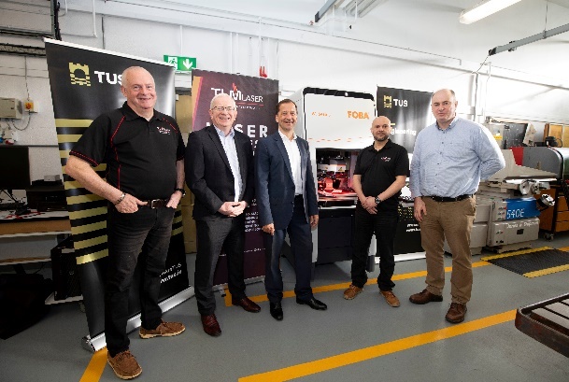
The FOBA M2000 marking workstation at Technological University of the Shannon (TUS).
(Copyright: Alan Place)

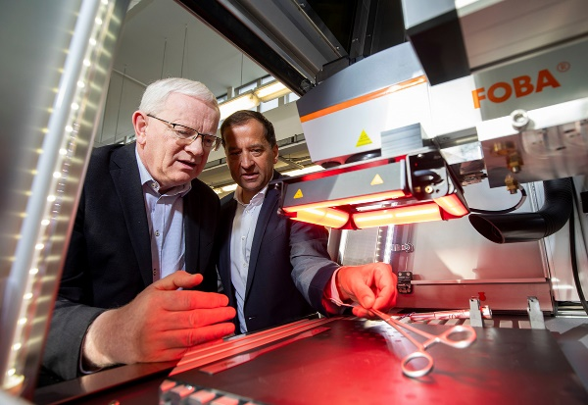

View into the FOBA M2000 laser marking machine.
(Copyright: Alan Place)

For additional information and images for editorial use please contact:

Kathrin Urban | Campaign & Event Manager
ALLTEC Angewandte Laserlicht Technologie GmbH | FOBA Laser Marking + Engraving
An der Trave 27 – 31 | 23923 Selmsdorf
Tel.: +49 (0)38823 55-440
kathrin.urban@fobalaser.com | www.fobalaser.com

