Press Release
January 15, 2018

Fast and flexible: FOBA’s new CO2-laser markers
High speed, highly variable material suitability, and flexible marking options are features of FOBAs new 10-Watt and 30-Watt laser marking systems C.0102 and C.0302.

Selmsdorf, January 2018 – FOBA Laser Marking + Engraving has further optimized the capability of its CO2-laser marking systems. In response to increasing demands for marking quality and speed, FOBA introduces 10 and 30-Watt lasers that mark a broad range of materials with highly variable contents. Over 20,000 available system configurations with three different optional wavelengths make the innovative FOBA CO2-laser markers C.0102 and C.0302 extremely versatile.

Easy-to-use mechanical components like detachable umbilical cables in different lengths allow for a smooth set-up within existing production facilities. Even in the toughest manufacturing environments, the laser head is safely protected against dust and humidity due to its IP65/IP54 cover and a powerful fume extraction unit.

The marking field size has been enlarged to a maximum size of 32.2 x 41.9 inches (600 x 440 millimeters), which is an unparalleled feature. Another distinguishing advantage is that the marking speed has been increased to 2000 characters or up to 900 meters (3000 feet) per minute. Therefore, FOBA’s C.0102/C.0302 systems are among the most efficient CO2 marking lasers, even compared to leading 60 Watt laser markers found on the market.

The fact that they require little maintenance, only a few consumables, boast a long life span of the air-cooled laser beam source, and provide pinpoint adjustable energy settings, also contribute to highly economic marking.

FOBA’s new C-Series CO2-laser markers are most appropriate for plastic part marking, in the packaging or electronic industries, but also for metal part processing. The constant further development and optimization of FOBA’s laser systems is driven by and based on decades of close cooperation between FOBA’s research and development team with international customers from various industries.

Alltec GmbH | FOBA Laser Marking + Engraving
www.fobalaser.com

Pictures for editorial use:

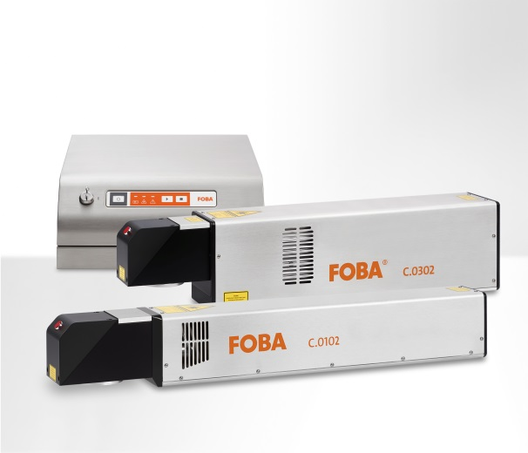
FOBA C.0102 and C.0302, 10- and 30-Watt-CO2-laser marking systems of the latest generation, offering a wide range of marking solutions for different materials and contents.

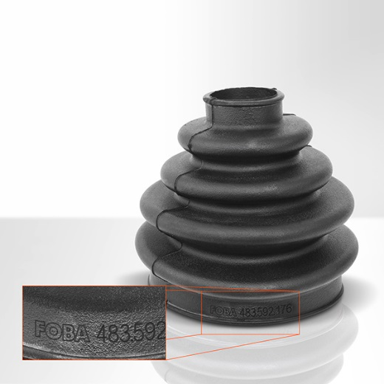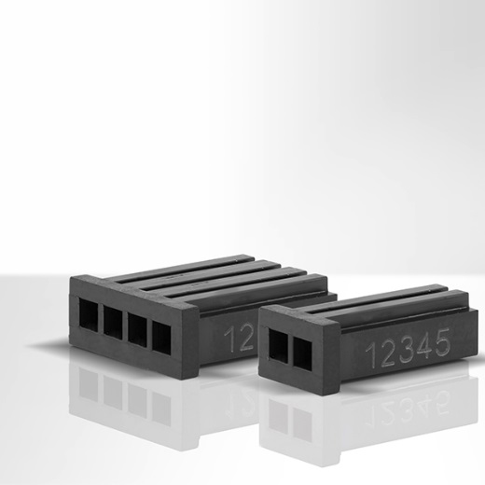
Plastic auto cuffs, laser marked Plastic plug-ins, laser marked
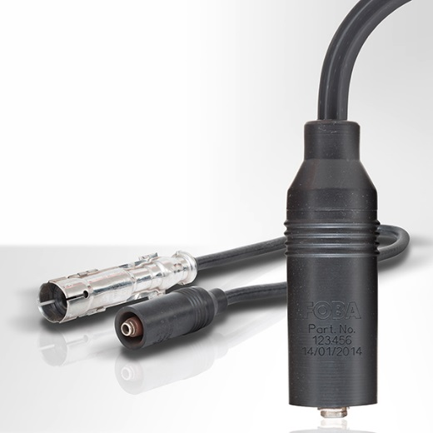 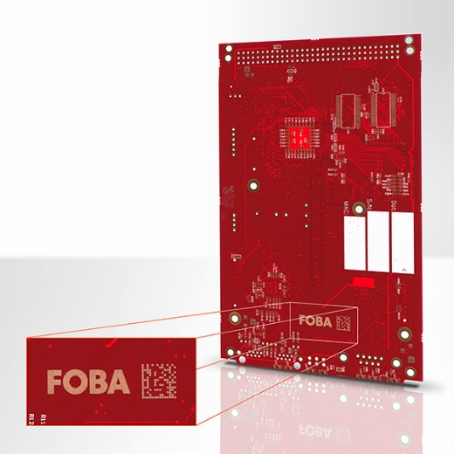
Ignition distributor with laser marks PC-board/printed circuit board

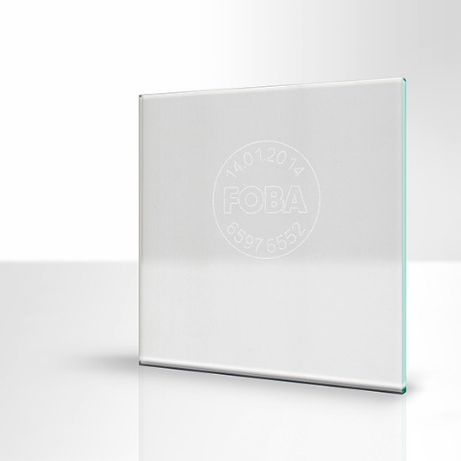 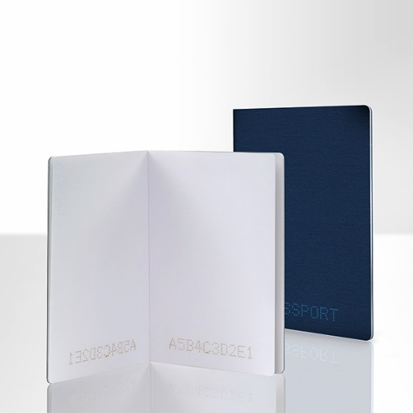
Window glass, laser marked Laser marking on paper and card board: passports

For additional information please contact:

Susanne Glinz | Campaign Manager
ALLTEC GmbH | An der Trave 27 – 31 | 23923 Selmsdorf/ Deutschland
Tel.: +49 (0)38823 55-547 | Fax: +49 (0)38823 55-222
susanne.glinz@foba.de | www.fobalaser.com

About FOBA Laser Marking + Engraving (Alltec GmbH) www.fobalaser.com
FOBA is one of the international market and technology leaders in manufacturing and supplying innovative laser systems for marking and engraving. Alltec/FOBA offers OEM laser markers, laser marking workstations and high-precision laser engraving machines, both standard- and customer-specific solutions. Since 2009, when Alltec was merged with FOBA, the brand name FOBA was consolidated and has become a strong common distribution and service label on international markets. With its headquarters in Selmsdorf/Germany, FOBA belongs to the US-based Danaher Corp., and serves the key markets of automotive part and medical device production as well as aerospace and others. FOBA marking lasers mark a variety of materials and parts in the fields of electronics, plastics processing, safety and ID, metal, tool and mold making and jewelry.

