Press Release
May 9, 2018

Next step in vision-based laser marking presented at the LASYS

FOBA is showcasing the latest innovation in automated mark alignment without product fixtures, a fiber laser for day-night-design and 100 Watt high-speed laser marking

Selmsdorf, May 2018 – At the LASYS (Stuttgart/Germany, June 5-7, 2018) FOBA Laser Marking + Engraving will be showcasing, before its official market launch, the latest innovation in vision-based automated laser positioning. The patent-pending software update enables the precise alignment of laser marks regardless of product positioning within the marking field.

The innovative feature will be demonstrated at stand 4B32, on a FOBA M1000 marking station to show that the need for custom accurate fixtures is in many instances unnecessary. This saves costs and will be available on the market after the upcoming launch of MarkUS marking software update version 2.12.

Another marking station on site will be a FOBA M2000-P, equipped with the innovative Y.0201-DN marking laser. This 20 Watt fiber laser was developed especially for the precise application of day-night-design elements on back-lit plastic components for automotive or electronic panels.

Beside the two M-Series marking stations, the powerful fiber laser marking system FOBA Y.1000 will also be at the show, which can easily be integrated into high-speed production lines. It is a 100 Watt-laser marker to be deployed especially for processing mass products and for the application of robust marks on high-wear parts.

Two of FOBA’s laser marking experts will hold lectures on June, 5, 2018: Christian Söhner, Global Market Manager Medical, will talk about UDI-compliant laser marking on medical products (Spectaris 10 x 10 Workshop, between 10:30 a.m. and 12:30 p.m.). Dr. Faycal Benayad-Cherif will introduce the latest innovative software function for automated mark alignment without product fixtures (Laser in Action Forum, 4 p.m.).

Visitors can pre-arrange an appointment at the show, please contact info@fobalaser.com or phone +49 38823 55-556.

Alltec GmbH | FOBA Laser Marking + Engraving

www.fobalaser.com

Pictures for editorial use:

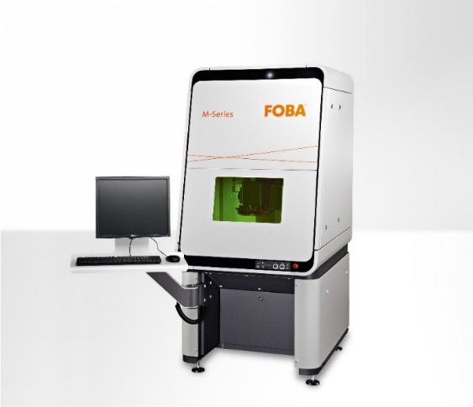
FOBA M2000, a laser marking station with optionally integrated camera

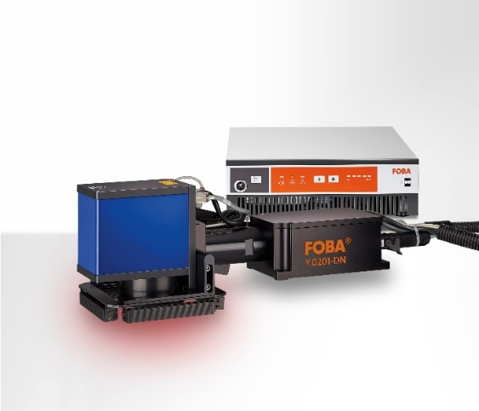
FOBA Y.0201-DN, an innovative fiber laser especially for the precise paint removal on coated plastics for day-night-design applications.

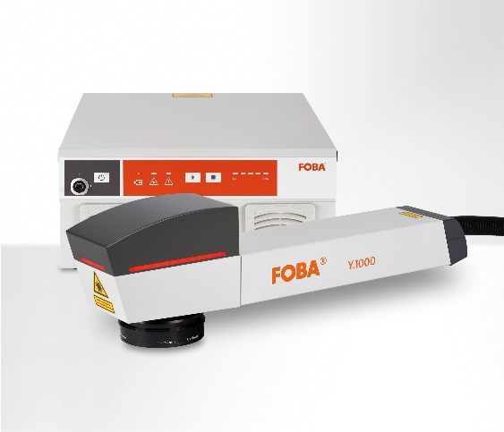
FOBA Y.1000, a 100 Watt marking laser for the integration into high-speed production lines

For additional information and to forward reader responses please contact:

Susanne Glinz | Campaign Manager
ALLTEC GmbH | An der Trave 27 – 31 | 23923 Selmsdorf/ Deutschland
Tel.: +49 (0)38823 55-547 | Fax: +49 (0)38823 55-222
susanne.glinz@foba.de | www.fobalaser.com

About FOBA www.fobalaser.com

FOBA Laser Marking + Engraving is among the leaders in manufacturing and supplying precision laser systems for marking and engraving. FOBA marking lasers mark a variety of materials and parts not least in the key markets of Automotive and Medical but also in Electronics, Plastics, Safety and ID. FOBA laser workstations for marking and engraving are especially applied in the fields of Automotive part production and Medical device marking as well as in Tool, Metal and Mold Making, Plastics processing and Jewelry. Worldwide sales and service branches service the most important markets.
In September 2009, FOBA has become part of ALLTEC GmbH. Since then, FOBA is part of ALLTEC as a sales channel for laser part marking and engraving.

