Press Release
February 05, 2018

FOBA strengthens position as a market leader for UDI laser marking in the medical industry
Proven expertise in compliant laser marking on surgical instruments and implants led to double-digit growth in 2017

Selmsdorf, February 2018 – Reviewing last year’s results, FOBA Laser Marking + Engraving has further strengthened its pole position as one of the leaders in laser marking technology for medical UDI (Unique Device Identifier) marking. FOBA’s proven expertise in the application and implementation of laser marks on surgical instruments and implants has been continuously challenged by growing regulatory marking and quality requirements as well as by the economic needs of medical devices manufacturers.

With double digit growth in the laser marking segment of the medical industry, FOBA partnered with nearly all of the top medical OEM manufacturers globally. FOBA’s M-series stand-alone marking solutions along with its diverse fiber lasers for integration, exceed demanding industrial standards of compliant marking on titanium, stainless steel and most of the medical plastics.

FOBA offers a vision based laser marking system with pre- and post-mark verification of components and marking results, which will significantly reduce marking errors while providing documented process stability. Automatic mark alignment relative to the position of the workpiece insures an economic and stable marking performance.

Christian Söhner (FOBA’s vertical manager, medical) emphasized the importance of good relationship management with all the different industry segments. “We listen to the needs of our customers, manufacturers, healthcare and regulatory bodies. Together with our long-standing technical experience, we are able to continuously enhance our laser marking and service solutions”, said Söhner, dedicated to growing confidence and customer loyalty in the medical industry.

Alltec GmbH | FOBA Laser Marking + Engraving
www.fobalaser.com

Pictures for editorial use:

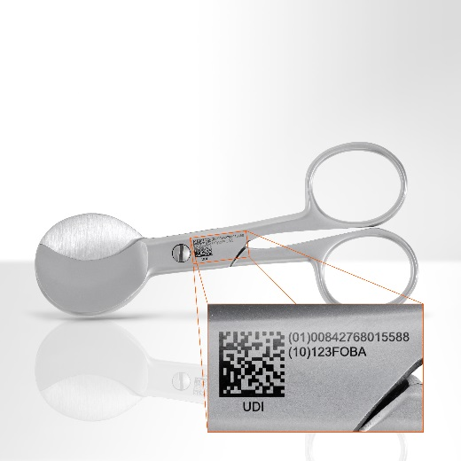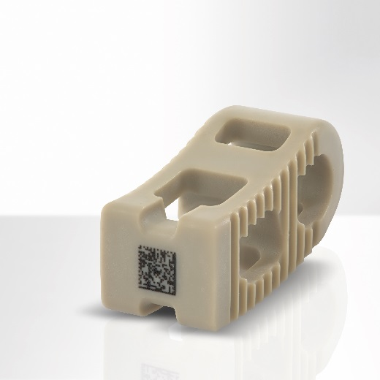
UDI-marking on stainless steel Data matrix code on a PEEK spine implant
umbilical cord scissors
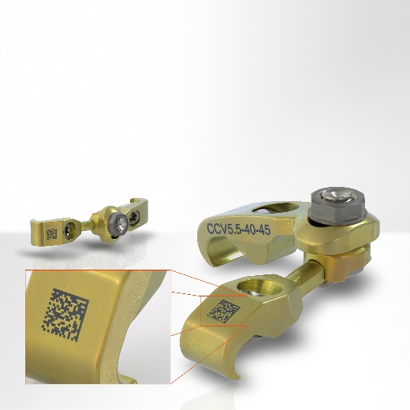 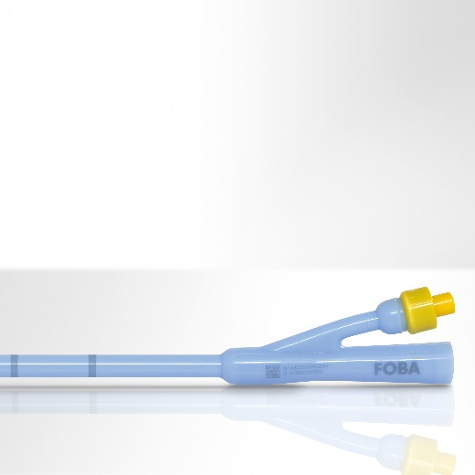
Laser marked Interbody connector Uromedical silicone balloon catheter, laser marked
for spinal fusion surgeries

For additional information please contact:

Susanne Glinz | Campaign Manager
ALLTEC GmbH | An der Trave 27 – 31 | 23923 Selmsdorf/ Deutschland
Tel.: +49 (0)38823 55-547 | Fax: +49 (0)38823 55-222
susanne.glinz@foba.de | www.fobalaser.com

About FOBA Laser Marking + Engraving (Alltec GmbH) www.fobalaser.com
FOBA is one of the international market and technology leaders in manufacturing and supplying innovative laser systems for marking and engraving. Alltec/FOBA offers OEM laser markers, laser marking workstations and high-precision laser engraving machines, both standard- and customer-specific solutions. Since 2009, when Alltec was merged with FOBA, the brand name FOBA was consolidated and has become a strong common distribution and service label on international markets. With its headquarters in Selmsdorf/Germany, FOBA belongs to the US-based Danaher Corp., and serves the key markets of automotive part and medical device production as well as aerospace and others. FOBA marking lasers mark a variety of materials and parts in the fields of electronics, plastics processing, safety and ID, metal, tool and mold making and jewelry.

