Press Release
January 03, 2018

High Laser Power for Robust Part Marking –
FOBA Introduces a 100-Watt Fiber Laser
Variable scan head tuning, configurable beam turn unit and various interfaces permit integration into nearly any existing production line

Selmsdorf, January 2018 – The new 100-Watt fiber laser FOBA Y.1000 operates up to 40 percent faster than common 50-Watt lasers and allows for marking substrates that are usually difficult to mark with other models. It applies robust marks on heavy wear products to ensure abrasion-proof legibility. Its compact design permits a smooth integration into existing production lines. Outlining its main benefits, FOBA’s new Y.1000 stands for a powerful high-performance, fast and precise part marking process.

The 100-Watt fiber laser is perfectly suited for marking and engraving automobile and aerospace components, because engraved marks are robust and ensure long-term legibility throughout the entire product life cycle. This applies to high-wear products like engine components, ball bearings, break systems or extruded products and cables. Best mark contrast and resistance qualities ensure reliable part traceability and protection against product forgery.

To meet different speed and contrast specifications for customized applications, four focal widths are available, allowing for adjustments to marking field dimensions as well as marking speeds.

Even for on-the-fly-marking (marking on moving products in continuous processing lines), it is possible to obtain marking field dimensions of up to 498 x 367 millimeters, thus enabling highly efficient marking with maximum throughput. The available large marking field also allows for the fast and effortless marking on large-sized components or for applying multiple marks on one product. All created marks are of a consistently high quality and accuracy. A unique, variable scan head tuning is available in two modes – for high-quality or high-speed purposes – and enables sharp marking results at line speeds of up to 600 meters/minute.

The laser beam can be positioned in two angles, either 90 degrees top down or zero degrees straight forward, which is an advantageous integration simplifying feature. Another integration benefit is the system’s compatibility with various interfaces like Ethernet and RS-323 or, from quarter 2/2018, also Profibus, Profinet and TCP/IP (with software version MarkUS 2.12). This makes it easy to set up software configuration for the integration into production lines.

The air-cooled system requires hardly any laser source maintenance, in contrast to the extended maintenance requirements of water-cooled systems. Furthermore, the laser source’s lifespan is significantly longer, compared to other high-power Nd:YAG-lasers with lamps or diodes, which need to be exchanged regularly. Downtimes due to laser source exchange are consequently as good as gone.

FOBA’s product manager Markus Vetter summarizes the benefits of the new Y.1000: “Our fiber laser marking technology enables maximum production efficiency and speed, while providing highest reliability and best-in-class marking quality. This system, which has been developed in close cooperation with our international customers, complies with demanding industrial standards.”

Alltec GmbH | FOBA Laser Marking + Engraving
www.fobalaser.com

Pictures for editorial use:

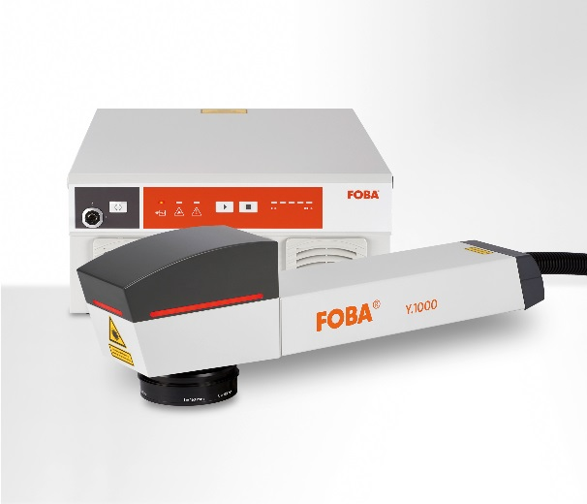

FOBA Y.1000, a compact fiber laser marking system, which can effortlessly be integrated into production lines and creates robust markings, even on hard-to-mark substrates.
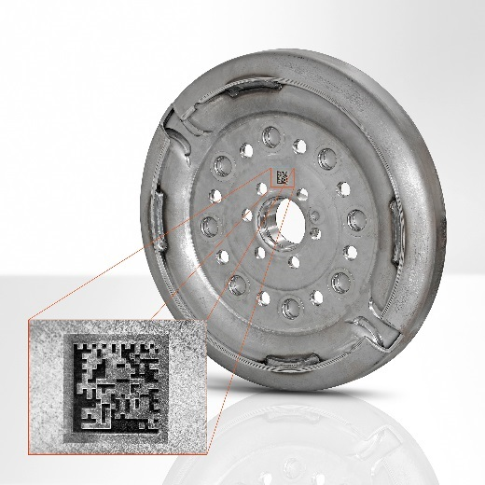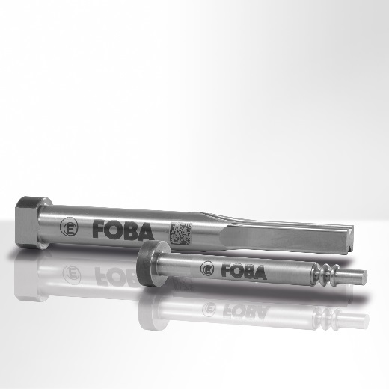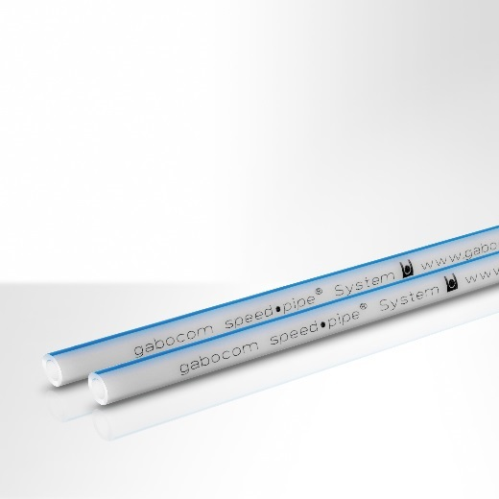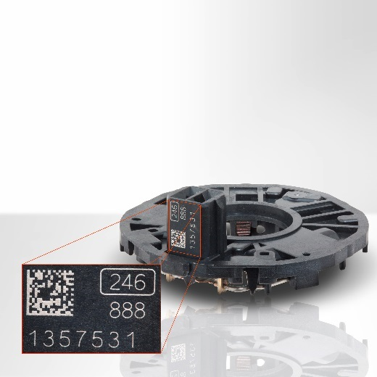

Heavy-wear metal or plastic components, e.g. for automotive or aerospace industries, laser marked utilizing the color change or engraving method. Robust and stable characters and codes can guarantee part traceability and forgery protection.

For additional information please contact:

Susanne Glinz | Campaign Manager
ALLTEC GmbH | An der Trave 27 – 31 | 23923 Selmsdorf/ Deutschland
Tel.: +49 (0)38823 55-547 | Fax: +49 (0)38823 55-222
susanne.glinz@foba.de | www.fobalaser.com

About FOBA Laser Marking + Engraving (Alltec GmbH) www.fobalaser.com
FOBA is one of the international market and technology leaders in manufacturing and supplying innovative laser systems for marking and engraving. Alltec/FOBA offers OEM laser markers, laser marking workstations and high-precision laser engraving machines, both standard- and customer-specific solutions. Since 2009, when Alltec was merged with FOBA, the brand name FOBA was consolidated and has become a strong common distribution and service label on international markets. With its headquarters in Selmsdorf/Germany, FOBA belongs to the US-based Danaher Corp., and serves the key markets of automotive part and medical device production as well as aerospace and others. FOBA marking lasers mark a variety of materials and parts in the fields of electronics, plastics processing, safety and ID, metal, tool and mold making and jewelry.

