Press Release
July 11, 2019

50 years of FOBA: From tool maker to laser product pioneer

Since its founding in 1969, the tool and machine manufacturer FOBA Laser Marking + Engraving (Alltec GmbH) has developed from a craft shop for mold making into one of the leading international providers of system solutions for laser marking. The anniversary year offers the opportunity to review the company's history as well as to look into the future of the internationally positioned company.

Selmsdorf, July 2019 – FOBA was founded in September 1969 in Lüdenscheid/Germany as a "mold making and engraving company" with 15 employees. Starting with mechanical engraving, FOBA has continued to develop the labeling of industrial products and components as a core business ever since. The basis for FOBA's expertise in the development of complex control systems was the production of hot runner control units and other electronic components. The first laser system developed by FOBA was launched in 1991 as a Nd: YAG marking laser.

Focusing solely on laser technology since 2001, FOBA has become one of the internationally leading providers of marking lasers with almost 250 employees worldwide. Its history is characterized by innovation and change despite its tradition. Continuous technical advancement of the laser systems, multiple relocation of the company sites as well as succeeding shareholders characterize FOBA until today.

In 2009, the Lübeck-based manufacturer of laser marking machines ALLTEC acquired the laser engraving specialist FOBA in Lüdenscheid. Two companies that focus on marking and engraving with lasers also took legal action in common – now within the framework of the ALLTEC GmbH.

The FOBA brand was also continued after the company consolidation and strengthened in 2011 by renewing and sharpening its brand image. Since 2014, the sole headquarters and production and development site lie in Selmsdorf near Lübeck. International service and sales are managed by the company headquarters and offices in the United States (Chicago) and China (Shanghai).

The international focus and growth of the company is further supported by FOBA's affiliation with the US Danaher Group. As part of the group’s Product Identification Platform, FOBA strives for innovative solutions for direct parts marking with lasers under the motto "bring products to life by harnessing laser technology".

FOBA’s main field of industrial activity is in the area of ​​sustainable marking of automotive components and medical technology products.

Technological Background:

The initially used solid-state and CO2 lasers were supplemented in 2004 by the first fiber laser in FOBA's product portfolio. Constant optimization of the material and technology know-how make these today the most powerful marking lasers. This allows FOBA's systems to label virtually any type of material in high quality with durable characters.

FOBA offers marking workstations as well as components for integration into production lines, which are optionally equipped with a marking head-integrated camera system for automated parts recognition and mark alignment. Special features of FOBA's camera-controlled marking units are the holistic marking principle HELP and IMP for the intelligent mark positioning as well as an innovative feature for laser marking without product fixtures.

FOBA's marking lasers, laser marking machines and vision-based marking workflows are used mainly in the automotive supply industry, medical technology, electronics and the plastics industry as well as in tool, metal and mold making to identify a large number of materials and products.

FOBA Laser Marking + Engraving
www.fobalaser.com

Find a timeline with the most important steps in FOBA’s company history at: https://www.fobalaser.com/about-foba/50-years/

Pictures for editorial use are available for free download: https://www.fobalaser.com/news-press/

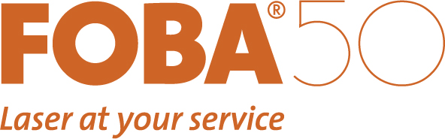
FOBA's logo is being supplemented by the 50 in the anniversary year, in order to consistently present the 50th anniversary (picture rights: FOBA)
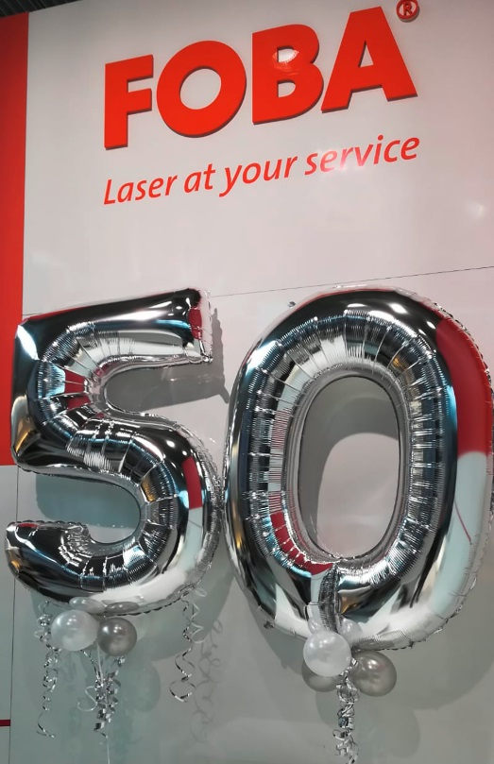

In 2019, FOBA Laser Marking + Engraving celebrates its 50th anniversary (picture rights: FOBA)

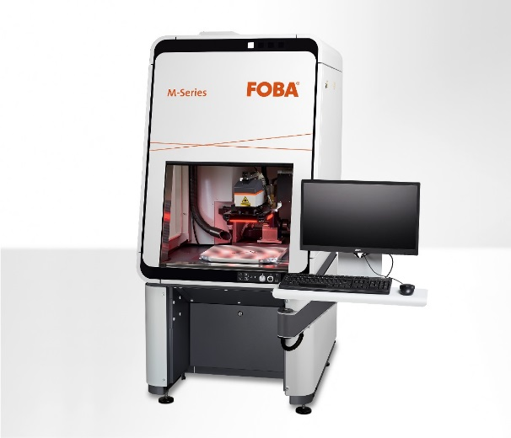

The laser marking workstation FOBA M2000 is one of the powerful marking systems of the FOBA M series (picture rights: FOBA)

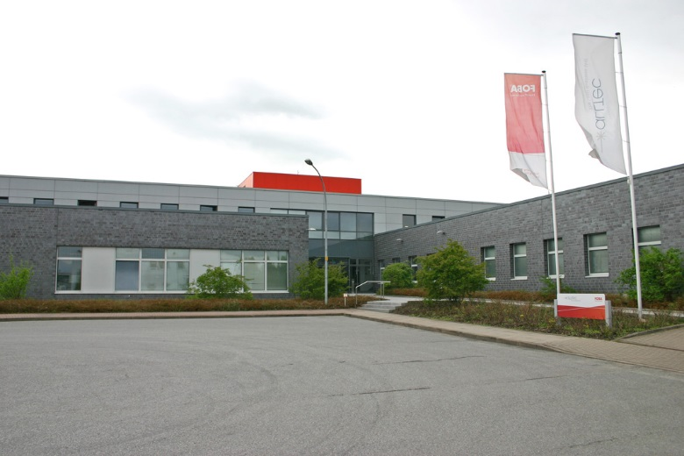

The ALLTEC facility in Selmsdorf near Lübeck. With the merger of ALLTEC and FOBA in 2009, Selmsdorf has become the sole production location. (picture rights: FOBA)

For additional information and to forward reader responses please contact:

Susanne Glinz | Campaign Manager
ALLTEC GmbH | An der Trave 27 – 31 | 23923 Selmsdorf/ Deutschland
Tel.: +49-(0)38823 55-547
susanne.glinz@fobalaser.com | www.fobalaser.com

About FOBA www.fobalaser.com
Alltec GmbH with its FOBA Laser Marking + Engraving brand is among the leaders in manufacturing and supplying innovative solutions for laser marking. FOBA`s marking lasers, laser marking workstations and vision assisted laser marking workflows mark a variety of materials and parts not least in the key markets of Automotive and Medical but also in Electronics, Plastics and Tool, Metal and Mold Making. Worldwide sales and service branches serve the most important markets. Since 2004, Alltec/FOBA – headquartered in Lübeck near Hamburg – is part of the US-based Danaher Corporation.

