Press Release
January 31, 2018

Better Patient Safety due to UDI-Marking on Medical Implants

Selmsdorf, January 2019 – Severe criticism against manufacturers of medical devices and related supervision processes occurred in November 2018, when European journalists questioned the reliability of implants and their possible effects on human health. The German inter-trade organization BVMed put this into perspective and additionally pleaded for an official nationwide implant database. FOBA encourages this approach and considers UDI-codes, firmly applied on medical implants, to be a key-factor for safe traceability of implants.

An implant database, like the already existing EPRD (Endoprothesenregister Deutschland) indicates quality standards and can prevent malfunctions of an endoprosthesis. Patient safety and product quality can significantly be improved if manufacturers and users (medical professionals, hospitals, patients etc.) provide information and report incidents consistently. A UDI (Unique Device Identification) makes every single implant explicitly traceable.

A UDI mark, applied directly and permanently on a medical product, is presently only mandatory for reusable and multi-reprocessed parts like surgical instruments. But also on implants, although often delivered sterile, a resistant and biocompatible UDI mark is of benefit for traceability when it comes to possible revision surgery in the case of malfunction.

Additionally the increasing digitalization in the health sector raises the importance of machine-readable UDI-codes directly on medical products. More and more users, e.g. in the complex environment of a hospital, request direct part marking with codes and other indicators for logistical reasons.

The manufacturers and distributors of medical devices are currently challenged to adapt their processes to the latest requirements of the European MDR, becoming mandatory as of 2020. There seems to be a tremendous need for consultation, especially regarding part marking with law-confirming appropriate UDI-codes. “We can support all medical device manufacturers in implementing a compliant marking process which also translates into providing the best possible safety for patients”, says Christian Söhner, FOBAs Global Vertical Manager Medical.

According to the 2017 annual report of Endoprothesenregister Deutschland (EPRD) about 63 percent of all endoprosthestic hip and knee joint surgeries in Germany have already been registered. A growth to over one million registrations is being estimated until the end of 2018, the aim according to the EPRD is a fully registration of all implantations. Despite its comparably short term of existence the EPRD is one of the worldwide largest registers (see EPRD annual report 2017).

Hospitals and medical professional are requested to contribute to the EPRD even more rigorously with the aim to track the lifespan (duration in the body) of the implants as completely as possible. German federal health minister Jens Spahn has recently pleaded for an official implant register, based on the already existing EPRD.

Whereas the EPRD basically covers all implantations and possible subsequent revision surgeries, the medical devices law also requires a compulsory registration for all incidents in the sense of product defects that actually threaten or are a potential threat for human health. The BVMed e.V. (Bundesverband Medizintechnologie) states that most incidents so far have been reported by the manufacturers and distributors. This shows that manufacturers and distributors are willing to account for the safety and quality of medical products.

FOBA’s vision-based laser marking systems make sure that all kinds of marks or (bar-)codes are applied in highest quality and permanency on any substrate. Manufacturers who use FOBA’s M-series laser marking machines benefit from a universal and comprehensive solution for UDI-code marking that also includes a pre- and post-mark validation of parts and marks.

FOBA Laser Marking + Engraving
www.fobalaser.com

Pictures for editorial use:

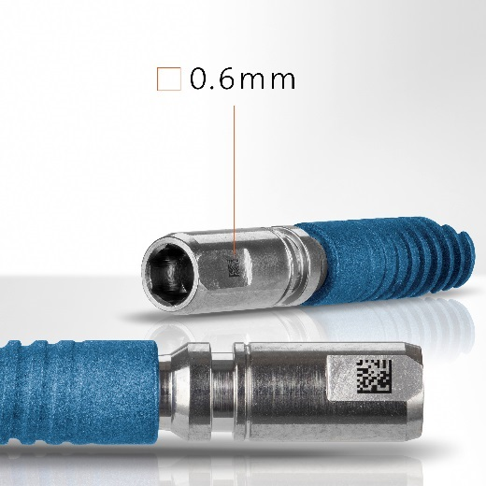
Dental implant with tiny UDI-code, laser marked (picture rights: FOBA)

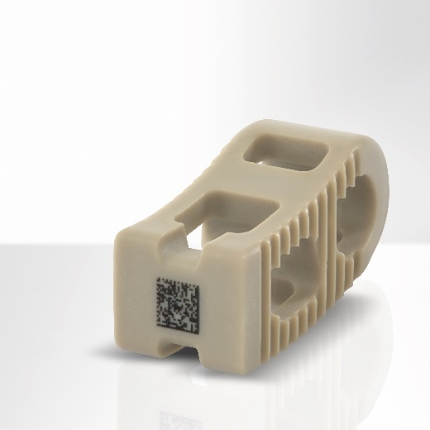
PEEK spine implant, laser marked (picture rights: FOBA)

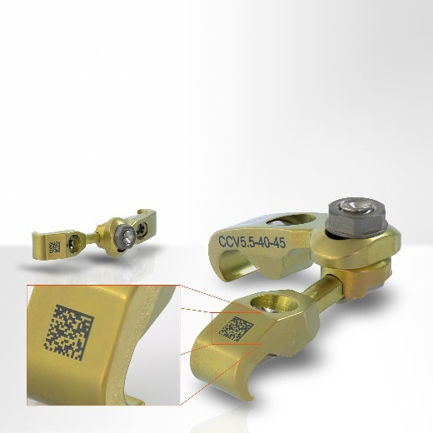
Titanium spine implant, laser marked (picture rights: FOBA)
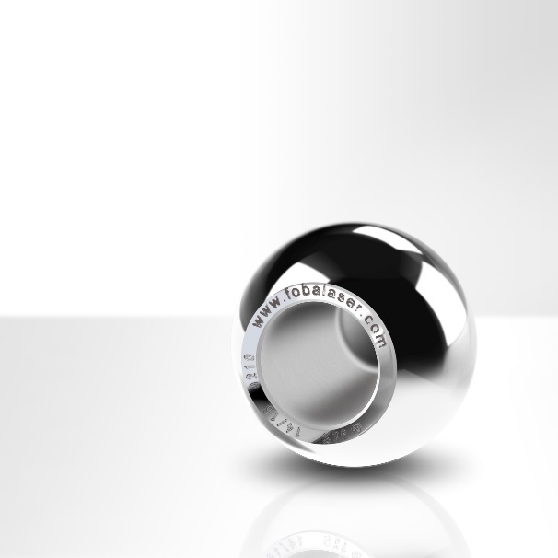
Laser engraved stainless steel hip ball implant (picture rights: FOBA)

For additional information and to forward reader responses please contact:

Susanne Glinz | Campaign Manager
ALLTEC GmbH | An der Trave 27 – 31 | 23923 Selmsdorf/ Deutschland
Tel.: +49-(0)38823 55-547
sglinz@fobalaser.com | www.fobalaser.com

About FOBA www.fobalaser.com
Alltec GmbH with its FOBA Laser Marking + Engraving brand is among the leaders in manufacturing and supplying innovative solutions for laser marking. FOBA`s marking lasers, laser marking workstations and vision assisted laser marking workflows mark a variety of materials and parts not least in the key markets of Automotive and Medical but also in Electronics, Plastics and Tool, Metal and Mold Making. Worldwide sales and service branches serve the most important markets. Since 2004, Alltec/FOBA – headquartered in Lübeck near Hamburg – is part of the US-based Danaher Corporation.

