Press Release
September 29, 2020

Almost lifelike: Industrial trade show visit as an avatar

Stroll through halls as an avatar, gather information at the booth, discuss live: At the "Virtual Manufacturing Day" on November 24 an innovative concept makes it possible to virtually experience automation solutions for industrial traceability.

Selmsdorf, September 2020 – The first Virtual Manufacturing Day 2020 on November 24 is aimed at manufacturing companies from the automotive, medical or electronics industries that are looking for automation solutions specifically for product tracking. The exhibitors will showcase innovations in optical quality control, robot-supported production, analysis and diagnostics, in the use of materials such as metal or plastic, and in laser marking.

A visit to the Virtual Manufacturing Day is closer to a real walk through the show than many of the current online formats: As an avatar, you enter a light-flooded exhibition hall, can speak live with other avatars, visit exhibition booths and listen to lectures. The environment is reminiscent of a computer game, but the focus of the concept development was not primarily on the entertainment character, but rather on the benefit for the visitors.

"We are using this innovative format for the first time and are looking forward to the virtual but almost lifelike exchange with our customers and business partners", says Dana Francksen, Marketing Director of FOBA, one of the leading manufacturers of laser technology for industrial direct part marking. FOBA is the event organizer and one of twelve exhibitors who provide personal contacts, product presentations and separate meeting areas on their virtual exhibition booths. In addition, hourly guided tours of the show are available and visitors are invited to join interesting lectures in the fair forum.

"A virtual trade show with a sophisticated spatial experience, where people exchange information not only in writing but also directly via sound, speech and visually, is an ideal event format in the current situation," says Frank Gläss, Managing Director of Glaess Software & Automation GmbH, the company that developed the innovative event platform. In order to offer visitors even more added value on November 24, the virtual trade fair "Smart Automation" organized by Glaess will take place at the same time (9 am - 5 pm) and in the same setting. "Those who visit the Virtual Manufacturing Day can also look around the Smart Automation Show in the adjacent hall. In this way, synergies are used for our visitors, competencies are bundled and virtual paths are shortened. There is hardly a more efficient way to spend a day at a trade show," adds Francksen.

Visitors will therefore benefit from looking around both halls for information on industrial automation, inspection or analysis technology, materials science, material processing, laser marking. It is also simple to communicate with other trade show participants whose name and company are visible on the person's avatar, by addressing them directly.

The participation is free of charge, the registration site is https://www.tom-meetings.com/event/virtual-manufacturing-day_en/ . In order to learn the "virtual running" fast, visitors can join short user trainings. In addition to hourly guided tours there is also a central information desk to help with orientation on the first "Virtual Manufacturing Day".

Participation as an exhibitor company is also possible at short notice, as there are few exhibition spaces still available. Questions about participation, organization or exhibition content will be answered by FOBA trade fair organizer Marion Pohlmann at marion.pohlmann@fobalaser.com

The most important facts in brief: Virtual Manufacturing Day 2020

When?
Tuesday, November 24, 2020, 9 a.m. – 5 p.m. CEST

Where?
Registration via
https://www.tom-meetings.com/event/virtual-manufacturing-day_en/

What will be on show?
Innovations for intelligent production in the fields of automation technology, optical quality control, analysis and diagnostics, materials (metal/plastic), laser marking, etc.

Who will be showcasing?
Exhibitors at the Virtual Manufacturing Day 2020 among others:
Zeltwanger Automation GmbH
Forécreu SAS
Merck KGaA
Laetus GmbH
BARLOG Plastics GmbH
Ara-Coatings GmbH & Co. KG
Viant Medical
FOBA Laser Marking + Engraving (Alltec GmbH)

Exhibitors at Smart Automation, Digital Trade Fair for Industrial Automation https://www.tom-meetings.com/event/smart-automation/ , among others:
Siemens AG
WAGO Kontakttechnik GmbH & Co. KG
All for One Group AG
EKS InTec GmbH
RAFI GmbH & Co. KG
Glaess Software & Automation GmbH

More Information:
Virtual Manufacturing Day 2020-Teaser-Video:
https://youtu.be/vO70v1T0l5w
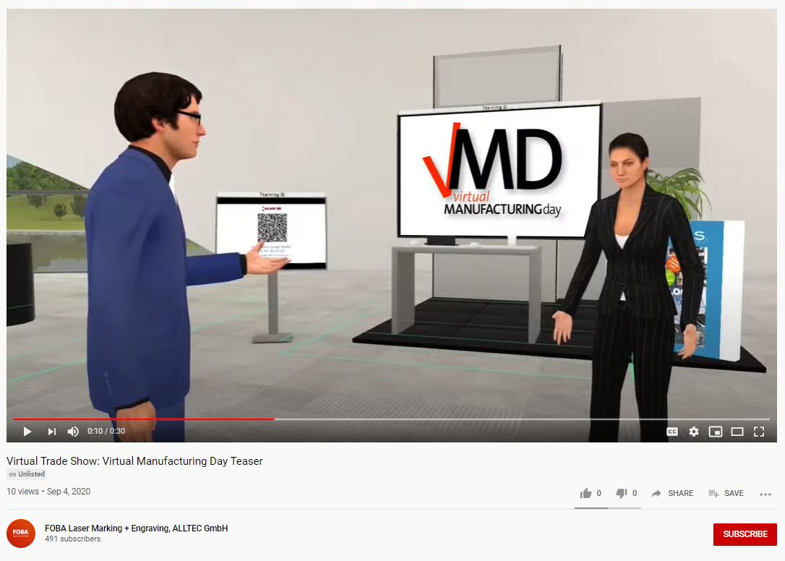

FOBA Laser Marking + Engraving
www.fobalaser.com/

Images for editorial use are available for download at: https://www.fobalaser.com/news-press/article/almost-lifelike-industrial-trade-show-visit-as-an-avatar/

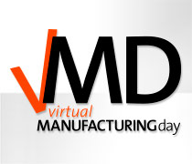
Logo/key visual „Virtual Manufacturing Day“

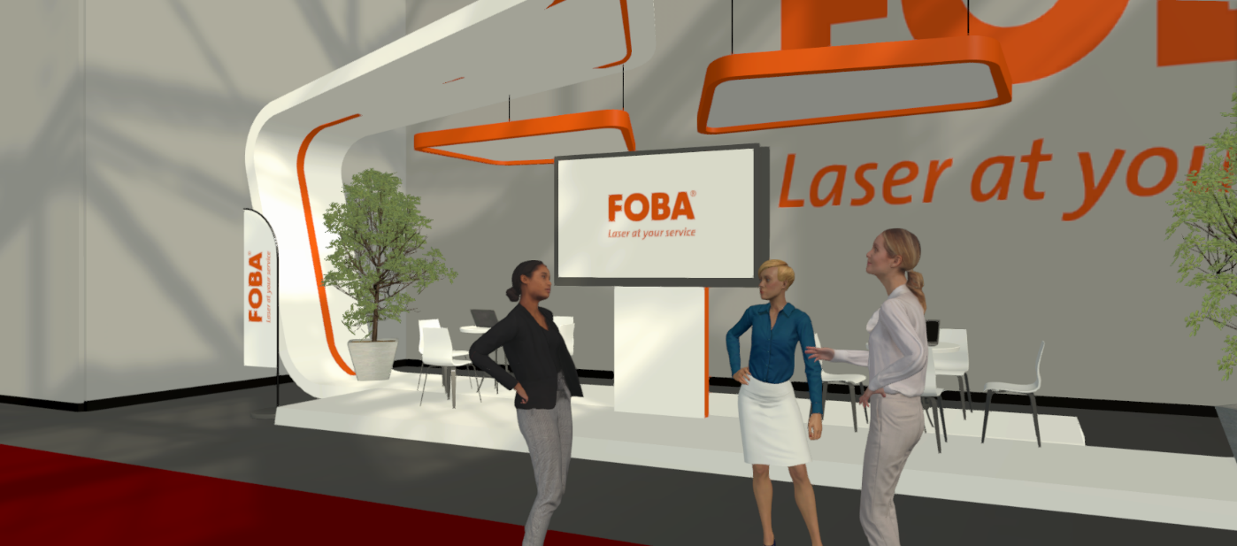
Live conversations at the booth can be conducted as an avatar at the Virtual Manufacturing Day.
(image rights: FOBA)

For additional information and to forward reader responses please contact:

Susanne Glinz | Campaign Manager
ALLTEC GmbH | An der Trave 27 – 31 | 23923 Selmsdorf/ Germany
Tel.: +49 38823 55-547
susanne.glinz@alltec-laser.com | www.fobalaser.com

About FOBA www.fobalaser.com
Alltec GmbH with its FOBA Laser Marking + Engraving brand is among the leaders in manufacturing and supplying innovative solutions for laser marking. FOBA’s marking lasers, laser marking workstations and vision assisted laser marking workflows mark a variety of materials and parts not least in the key markets of Automotive and Medical but also in Electronics, Plastics and Tool, Metal and Mold Making. Worldwide sales and service branches serve the most important markets. Since 2004, Alltec/FOBA – headquartered in Lübeck near Hamburg – is part of the US-based Danaher Corporation.

