Press Release
February 03, 2020

FOBA Upgrades Portfolio with New Y.0200-S Fiber Laser Marking System

Selmsdorf, February 2020 – FOBA Laser Marking + Engraving, a global leader in industrial laser part marking and engraving solutions, has introduced another laser marker for line integration: The new FOBA Y.0200-S model is an upgrade to the existing range of fiber laser marking systems. The powerful marking laser is characterized by its compact design and gives manufacturers a high amount of marking and mounting versatility.

FOBA understands manufacturers’ varying needs for direct part marking and intends to solve many of their unique laser identification requirements. The new system is ideal for demanding production schedules – especially in the electronics and automotive supplies or metal and plastics processing industries. FOBA’s Y.0200-S marking system can keep pace with the legal ID specifications and provide a high level of code contrast and durability, even on robust, high-density materials.

The 20-Watt fiber laser provides increased operational freedom, flexibility and application confidence. Users can select either a 6 mm marking head for high-speed production or a 10 mm marking head for parts marking with fine detail.

Improved data processing and high marking speed allow for enhanced productivity: Up to 1,300 characters per second can be achieved with the 6 mm marking head or up to 1,000 characters per second with the 10 mm marking head, depending on the application.

The new laser provides seamless integration into various production lines and users can choose to control the marking process using FOBA’s Touch Control Software FOBA Go on the IP65-rated 10.1-inch color touchscreen or on most browser-based devices.

“Our customers have already received this lightweight, compact and agile fiber laser solution very well”, said Wen Xiao, FOBA General Manager in the APAC region. “Having the choice between a zero or 90 degree marking head orientation, they benefit from versatility in tight spaces and easy mounting of one of the smallest marking heads available.”

FOBA Laser Marking + Engraving
www.fobalaser.com

Pictures for editorial use can be downloaded at: https://www.fobalaser.com/news-press/article/foba-upgrades-portfolio-with-new-fiber-laser-marking-system/

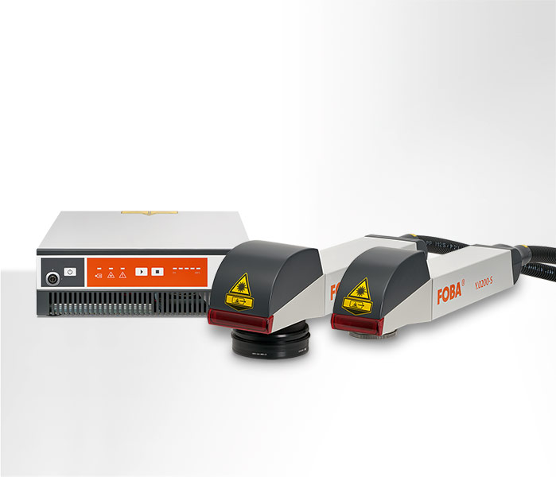
FOBA Y.0200-S laser unit and marking heads with Zero and 90 degree beam exit orientation.
(image rights: FOBA)

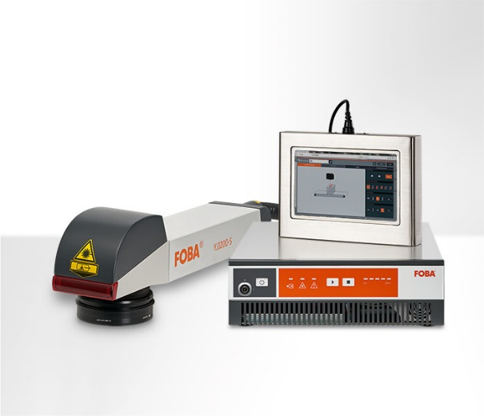
The FOBA Y.0200-S marking unit can be controlled using the IP65-rated 10.1-inch color touchscreen laser controller. (image rights: FOBA)

For additional information and to forward reader responses please contact:

Susanne Glinz | Campaign Manager
ALLTEC GmbH | An der Trave 27 – 31 | 23923 Selmsdorf/ Germany
Tel.: +49-(0)38823 55-547
susanne.glinz@alltec-laser.com | www.fobalaser.com

About FOBA www.fobalaser.com
Alltec GmbH with its FOBA Laser Marking + Engraving brand is among the leaders in manufacturing and supplying innovative solutions for laser marking. FOBA`s marking lasers, laser marking workstations and vision assisted laser marking workflows mark a variety of materials and parts not least in the key markets of Automotive and Medical but also in Electronics, Plastics and Tool, Metal and Mold Making. Worldwide sales and service branches serve the most important markets. Since 2004, Alltec/FOBA – headquartered in Lübeck near Hamburg – is part of the US-based Danaher Corporation.

