Press Release
April 21, 2020

FOBA supports manufacturers with webcasts and flexible marking solutions during the crisis

Fast provision, uncomplicated financing models and extended service make it easier to cope with production peaks

In FOBA’s webinar series, laser marking experts offer direct part marking backgrounds and practical application knowledge

Laser marking ensures safe traceability as well as counterfeit protection

Selmsdorf, April 2020 – FOBA Laser Marking + Engraving (Alltec GmbH) offers support for manufacturers that need to cope with special requirements in the corona crisis. The company, which is a leader in the market for industrial part marking and engraving with laser technology, provides flexible investment models for a quick and easy deployment of additional marking systems.

“We are aware that many of our customers are currently struggling with declining orders, but at the same time see the increasing demand in certain areas such as the medical industry. We recognize this social responsibility and want to help as best we can,” says Managing Director Stefan Heczko. This applies particularly to medical device manufacturers whose production is ramping up or who are changing their portfolio due to current demands, which often results in an increased need for direct part marking.

FOBA responds to this with economical and uncomplicated loan and leasing offers as well as extensive remote service, online training and webinars, but also on-site installation help. For the first time FOBA is offering short-term machine rentals for medical device manufacturers. Depending on the actual requirements, appointed rental or leasing models can also be extended to purchase, which gives maximum flexibility in terms of machine availability. The offer applies to FOBA's closed marking workstations or to marking systems that are integrated into production lines.

In order to use the time in the home office as profitably as possible, FOBA offers a series of webinars in April, May and June. Customers and interested parties will then also receive detailed information on laser marking with a focus on UDI labeling of medical devices in accordance with the requirements of the MDR. More information about FOBA’s webinars and regular updates can be found at https://www.fobalaser.com/webinar/

FOBA's camera-based marking solutions are optionally offered as part of the M-Series closed marking workstations or of the safety class 4 marking systems for line integration. In this area, FOBA has recently launched innovative new solutions to the market, including FOBA Titus™, the world's smallest marking head. This makes installation in the production line easy due to its flexibility, simple assembly using clamp brackets and, above all, the extremely small space requirement.

FOBA's laser marking systems keep pace with the legal requirements for traceability and create codes with high contrast and long durability, even on products that must not corrode and are subject to heavy use, e.g. through repeated sterilization. A capable marking software enables connection to all common industrial interfaces.

FOBA Laser Marking + Engraving
www.fobalaser.com

Pictures for editorial use can be downloaded at: https://www.fobalaser.com/news-press/article/foba-supports-manufacturers-with-flexible-marking-solutions-during-the-crisis/

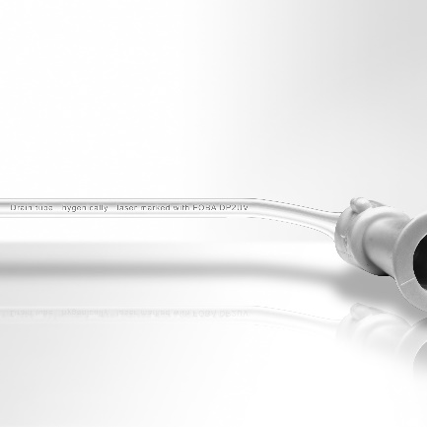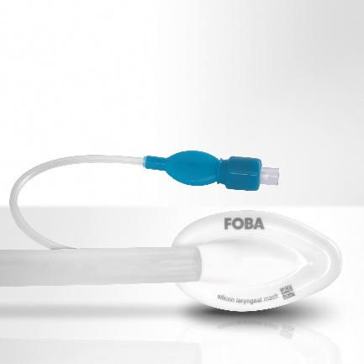
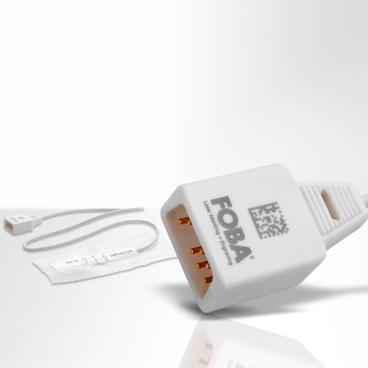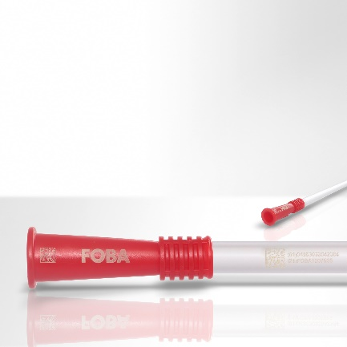

Medical device plastic accessories with laser marked UDI codes. (image rights: FOBA)

Christian Söhner, FOBA‘s Global Vertical Manager Medical, holds webinar lectures about MDR-compliant UDI-marking of medical devices. (image rights: FOBA)

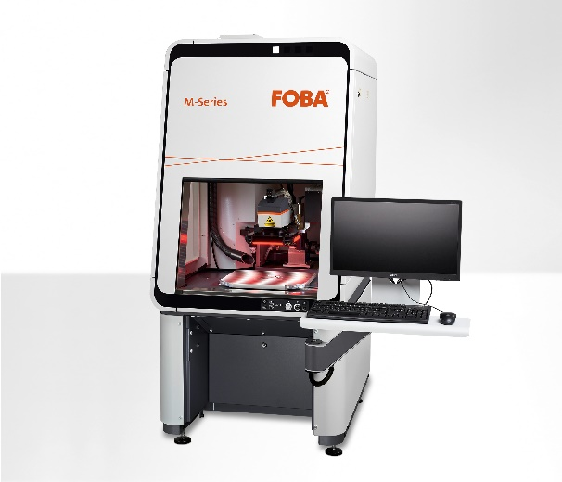
FOBA M2000 closed marking station can optionally be equipped with an integrated camera for automated mark alignment. (image rights: FOBA)

For additional information and to forward reader responses please contact:

Susanne Glinz | Campaign Manager
ALLTEC GmbH | An der Trave 27 – 31 | 23923 Selmsdorf/ Germany
Tel.: +49-(0)38823 55-547
susanne.glinz@alltec-laser.com | www.fobalaser.com

About FOBA www.fobalaser.com
Alltec GmbH with its FOBA Laser Marking + Engraving brand is among the leaders in manufacturing and supplying innovative solutions for laser marking. FOBA`s marking lasers, laser marking workstations and vision assisted laser marking workflows mark a variety of materials and parts not least in the key markets of Automotive and Medical but also in Electronics, Plastics and Tool, Metal and Mold Making. Worldwide sales and service branches serve the most important markets. Since 2004, Alltec/FOBA – headquartered in Lübeck near Hamburg – is part of the US-based Danaher Corporation.

