Press Release
November 02, 2021

Customized Automation Solutions in Laser Marking
– Webinar Replay available
From mark alignment software to tray infeed modules: Laser marking automation goes beyond robotics

Selmsdorf, November 2021 – In a recent webinar, laser marking system provider FOBA presented various technical solutions for the automation of an industrial laser marking process. Such solutions include laser integrated software features, semi or fully automated robot-assisted operation, product-dedicated marking units as well as marking-on-the-fly processes.

Going along with increasing traceability marking requirements, there is a growing need for direct part marking throughout all industries. The automation of part handling or mark alignment in a laser marking process can help improve marking quality, save time, and minimize production cost. Therefore, laser marking system providers offer technical solutions, some in cooperation with automation experts, that make laser marking even more efficient.

To provide an overview of the different ways of automation in laser marking, FOBA offered an expert webinar with Dr. Faycal Benayad-Cherif, who developed several patented laser marking solutions. This webinar has been recorded and is available at https://www.fobalaser.com/newsroom-events/webinar/udi-expert-talk-automation-and-medical-device-manufacturing-what-you-need-to-know/

Automation processes related to laser marking include the loading and unloading of a marking station from the outside, pick and place operations within a closed marking unit, but also stacking, sorting or a subsequent packaging and cleaning as well as line production of large batches. A distinction is made between semi-automated and fully automated systems, which differ in the degree of human interaction required.

Beyond that, the automation of the marking process itself plays an important role. This primarily involves the exact positioning of the laser mark at the intended position on the product. With the help of an integrated camera and corresponding software it is possible not only to minimize human interaction, but also to make the process repeatable with consistent accuracy.

"As a pioneer in the field of camera-based laser marking, FOBA has already enabled a certain degree of automation of the marking process for many years," says product manager Markus Vetter. This primarily concerns the mark alignment through automated optical part recognition, enabling the exact placement of the mark in relation to the component, as well as software-controlled inspection from the beginning to the end of the marking process.

Process control through camera and software features

Certain software functions such as Mosaic™ (patented), part of the FOBA MarkUS marking software, are capable of accurately marking a product located anywhere in the marking field. This not only saves time and the effort of manually aligning the part to the laser, but also the considerable cost of designing, manufacturing, validating, and maintaining production fixtures.

In medical device manufacturing there is a significant variation in terms of types, materials and shapes of products. In addition, the large numbers of SKUs (Stock Keeping Units) combined with small batch sizes can make the production process more complicated. Consequently, the requirements for marking and the degree of automation of the marking process will vary.

“By expanding our portfolio to include semi-automated loading and unloading processes, FOBA is further meeting current customer needs for automation," adds Markus Vetter, referring to cooperations with robot manufacturers and automation partners.

The technical integration of a laser marking system and a robot or automation system needs smooth interfaces. "At FOBA, all elements of the marking process, including the camera and illumination, are controlled by a single software. This means that our customers do not operate their process with different programs, which is an advantage in many cases," says sales manager Son Tran. Furthermore, the integrated camera solution reduces the effort of validating the marking process, as no additional validation for a separate camera software is required for medical device part marking.

Semi-automated loading and unloading

A case study shows what a robot-assisted semi-automated laser marking solution can look like: an industrial robot removes a tray containing several parts to be marked from a carrier cart and places it in a M2000-P marking station. The spacious marking field as well as the camera-assisted mark alignment enable the subsequent marking of several parts in one pass.

In the laser, the integrated camera takes over the automated inspection of all parts, the alignment of the position of the marking and the exact marking. The marking software can identify the shape, size, or incorrect assignments and, if necessary, distinguish individual parts to be excluded from the marking. After laser marking, the station access door opens, the robot removes the tray and reassigns it to the original insertion location in the service cart.

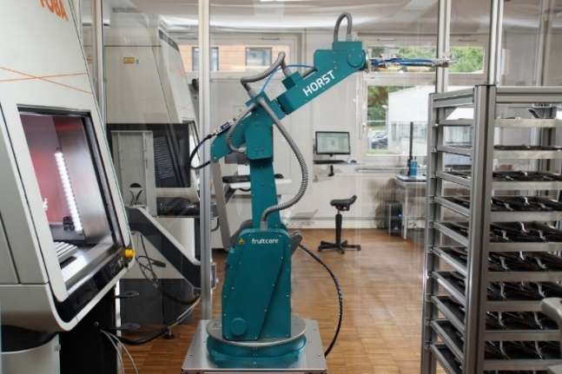
Image rights: fruitcore robotics
Caption: The industrial robot "Horst" from fruitcore robotics loads and unloads the FOBA M3000 laser marking station at the laser marking service provider add'n solutions in Tuttlingen, Germany

The case study featuring marking service provider add'n solutions and industrial robot provider fruitcore robotics is available at https://www.fobalaser.com/applications/case-studies/robotic-loading-automation/

Docking modules for highly flexible part processing

Other particularly flexible and fully automated marking solutions are based on a docking module that is connected directly to the FOBA M-Series marking workstations (M2000 or M3000). The docked automation cell is adapted to the marking workstations in terms of format and appearance and can be loaded with up to 20 pallets, which are individually drawn into the marking unit via linear kinematics.

"The advantages of these infeed systems are their relatively small footprint and ease of operation due to the elimination of additional programming work for an external robot gripper arm. Instead, a tablet infeed is fully integrated into the loading unit," explains Markus Vetter. In addition, these "WeStore" modular systems from Swiss automation specialist Wenger could also be operated manually in the classic way via the front door of the M-Series marking station, for example for manual processing of small batches.

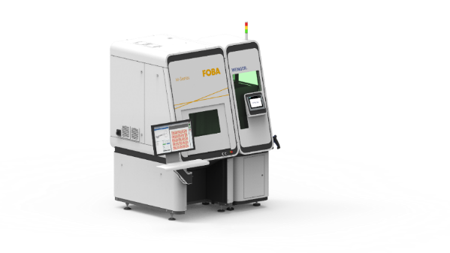
Image rights: Wenger Automation & Engineering AG
Caption: Docking modules from Wenger are a perfect complement to FOBA's laser marking stations: loading is carried out by automated tablet feed or an integrated robotic gripper arm

Stack loading and special software solutions

More common solutions are special machines developed inhouse for automated stack tray loading: "For our core market of plastic paint removal, so-called day-night marking, we have developed a solution for parts processed continuously on carrier trays," explains product manager Markus Vetter. This involves the production of small parts that are previously provided in larger quantities on stackable carrier trays. Autonomous gripping and loading systems supply the marking system with large volumes of parts, enabling several hours of operator-free production.

When it comes to software, marking systems try to enable individual solutions in each case. There are applications, especially small batch sizes or parts that are particularly delicate or demanding in terms of marking, when a robotic solution does not make sense and humans cannot be replaced. But even without robotics, a marking process can be streamlined using optional extras to make marking system more efficient.

For example, a rotary unit can greatly simplify the marking of cylindrical parts. This has been achieved at U.S. company Centex Machining with the help of an M3000 marking station. "We have integrated a marking process that previously required twelve individual manufacturing steps and 18 hours of marking time into the marking station," explains Centex’s production manager. The entire process now takes just three hours (two hours of setup time and one hour of marking time).

To learn more about how to solve cylindrical parts marking challenges the Case Study "Laser marking solution with rotary unit at Centex Machining" is available at: https://www.fobalaser.com/applications/case-studies/case-centex-machining/

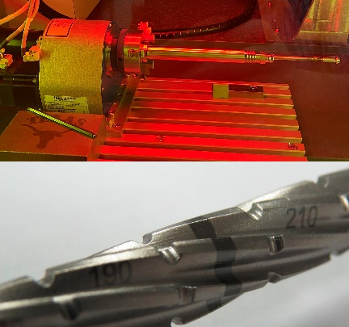
Image rights: FOBA
Caption: A rotary unit enables circumferential laser marking of cylindrical parts such as a bone screw.

The selection of the appropriate marking system and possible automation depends on the type and quantity as well as the material of the workpieces, the required size of the marking field and the desired visual inspection before, during and after marking. The integration of camera-enabled automated process control makes direct part marking a safe and comprehensive process. More information about the automation of laser marking can be found at https://www.fobalaser.com/products/automation/

Pictures for editorial use can be downloaded: https://www.fobalaser.com/newsroom-events/news-press/customized-automation-solutions-in-laser-marking-webinar-replay-available

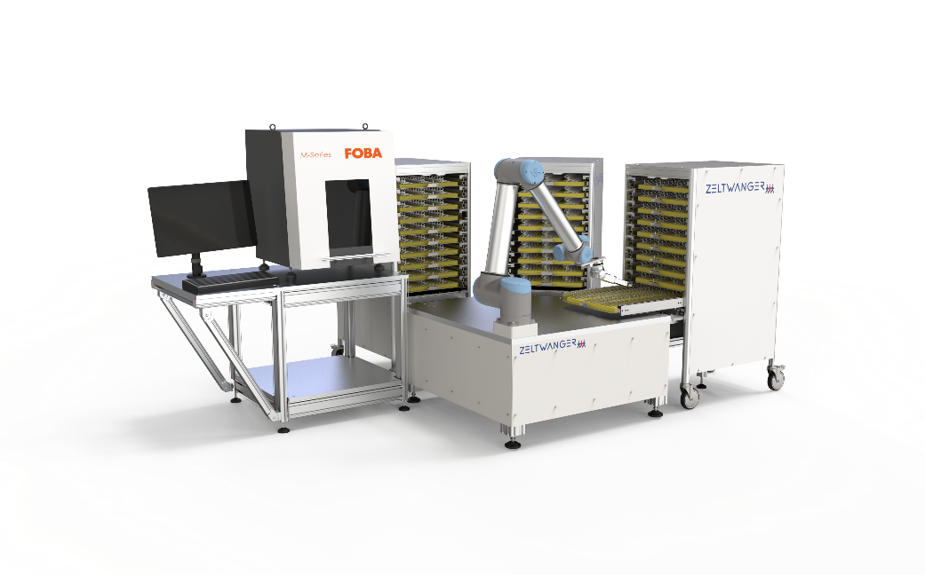
Image rights: ZELTWANGER
Caption: FOBA M2000 laser marking station and Zeltwanger’s industrial cobot integrated into a laser marking process.

Image rights: FOBA
Caption: Dr. Faycal Benayad-Cherif, Global Strategic Account Manager at FOBA Laser Marking + Engraving, is an expert in laser marking automation.

For additional information and images for editorial use please contact:

Susanne Glinz | Campaign Manager
FOBA Laser Marking + Engraving | brand of ALLTEC Angewandte Laserlicht Technologie GmbH
An der Trave 27 – 31 | 23923 Selmsdorf/Germany
Tel.: +49 38823 55-547
susanne.glinz@fobalaser.com | www.fobalaser.com

About FOBA www.fobalaser.com
FOBA Laser Marking + Engraving (brand of ALLTEC Angewandte Laserlicht Technologie GmbH) is one of the leading suppliers of advanced laser marking systems. FOBA develops and manufactures marking lasers for integration as well as laser marking workstations with vision assisted marking workflows. FOBA technology is being applied for the direct part marking of any kind of metals, plastics or other materials in industries like automotive, medical, electronics, plastics or tool, metal and mold making. With its worldwide sales and service branches and its headquarters near Lübeck/Hamburg (Germany) ALLTEC/FOBA is part of the Danaher Corporation.

