Press Release
October 26, 2021

Innovative Laser Marking Applications from FOBA at the automotive interiors EXPO

From paint removal on a modern glass display with touch function to engraving on a plastic component: Laser marking offers various possibilities for the functional and decorative design of a vehicle interior. FOBA exhibits latest laser marking applications for the automotive industry at the automotive interiors EXPO in Stuttgart/Germany from November 9 - 11, 2021.

Selmsdorf, October 2021 – At FOBA's booth A4365, visitors can experience the M2000 marking workstation on site. FOBA’s trade show team provides live demonstrations on the machine to inform about FOBA Mosaic, a software feature for accurate mark alignment on one or more sample parts, regardless of how they are positioned in the marking field. With the help of the integrated camera, the software simulates a distortion-free imaging and thus enables precise part recognition and automated mark alignment.

In addition, FOBA, together with project partner Marquardt, is presenting a pioneering touch panel made of 3D-molded glass. The control panel is backlit and has been laser marked by means of laser paint ablation. The resulting unique look creates a special vehicle ambience thanks to the metallic surface and a new type of lighting technology.

At info@fobalaser.com it is possible to make an appointment for an individual consultation and request a discounted trade fair ticket. Further information about the show can be found at https://www.automotive-interiors-expo.com/en/index.php and about project partner Marquardt’s touch panels at https://www.marquardt.com/us/solutions/operating-components-hmi/touch-operating-units/

FOBA Laser Marking + Engraving
www.fobalaser.com/

Images for editorial use can be downloaded at: https://www.fobalaser.com/newsroom-events/news-press/innovative-laser-marking-applications-from-foba-at-the-automotive-interiors-expo/

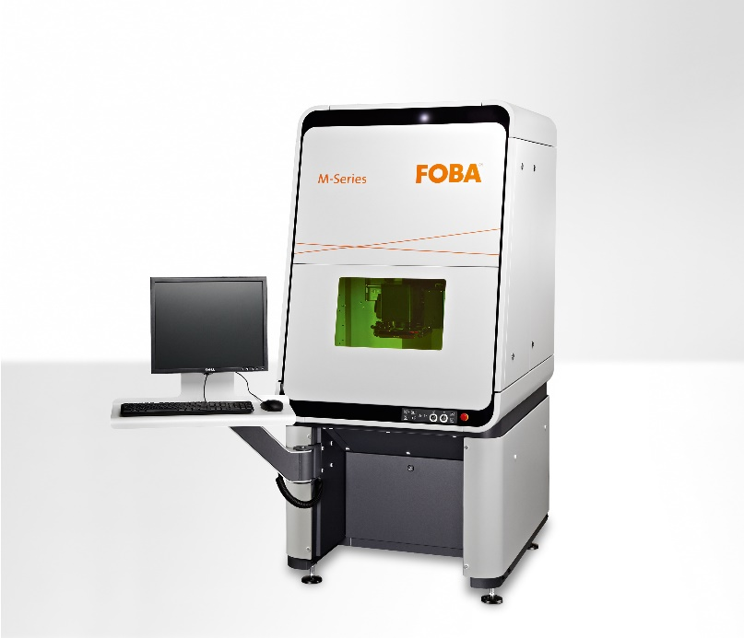

The FOBA M2000 closed marking workstation is classified laser protection class 1 and can optionally be supplied with the Mosaic software function. (Image rights: FOBA)

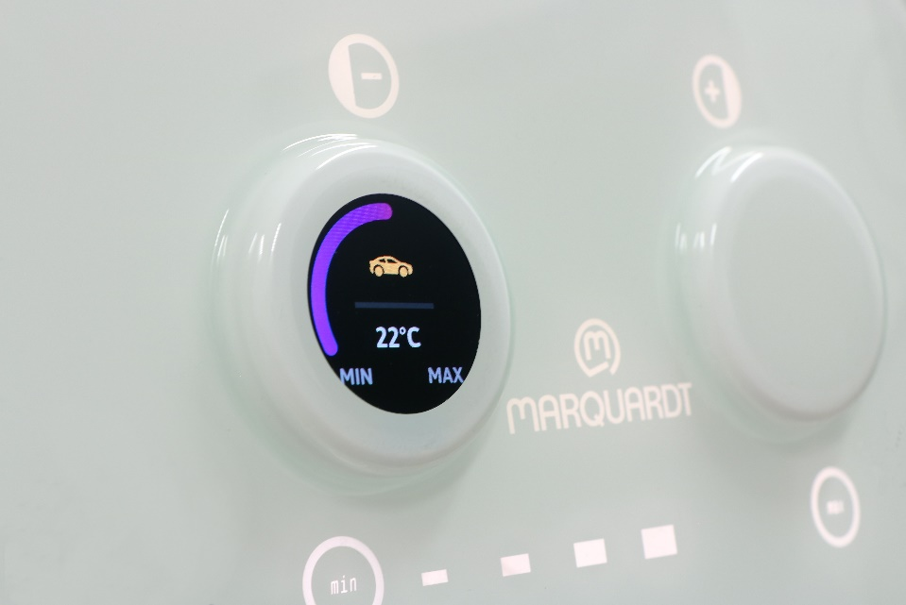
Laser-marked control panel on the backlit touch control unit from mechatronics specialist Marquardt, featured on FOBA's booth at automotive interiors EXPO. (Image rights: Marquardt)

For additional information and images for editorial use please contact:

Susanne Glinz | Campaign Manager | FOBA Marketing Communications
ALLTEC Angewandte Laserlicht Technologie GmbH
An der Trave 27 – 31 | 23923 Selmsdorf
Tel.: +49 (0)38823 55-547
susanne.glinz@fobalaser.com | www.fobalaser.com

About FOBA www.fobalaser.com
FOBA Laser Marking + Engraving (brand of ALLTEC Angewandte Laserlicht Technologie GmbH) is one of the leading suppliers of advanced laser marking systems. FOBA develops and manufactures marking lasers for integration as well as laser marking workstations with vision assisted marking workflows. FOBA technology is being applied for the direct part marking of any kind of metals, plastics or other materials in industries like automotive, medical, electronics, plastics or tool, metal and mold making. With its worldwide sales and service branches and its headquarters near Lübeck/Hamburg (Germany) ALLTEC/FOBA is part of the Danaher Corporation.

About Marquardt
Marquardt, a family-run company founded in 1925 and based in Rietheim-Weilheim, Germany, is one of the world’s leading manufacturers of electromechanical and electronic switches and switching systems. The products of the mechatronics expert are used by many well-known customers in the automotive industry and include operating components, vehicle access, driver authorization systems and battery management systems. The company’s systems are also used in household appliances, industrial applications and power tools. Marquardt Group employs approximately 10,600 members of staff worldwide at 20 locations in four continents. The company generated 1.2 billion euros sales revenue in the fiscal year 2020. Each year, Marquardt invests around ten percent of its revenues in research & development.

