Press Release
October 18, 2021

FOBA presents Titus™ at Productronica in Munich

Minimum space requirement, maximum marking quality – FOBA will demonstrate these and more benefits of the world's smallest laser marking head Titus™ during the electronics trade show Productronica from November 16 to 19, 2021. Latest marking software developments as well as solutions for the automation of the marking process are further key topics at the FOBA booth no. B2.207.

Selmsdorf, Oktober 2021 – At Productronica, one of the world's leading trade fairs for electronics development and production, FOBA will be exhibiting not only the flexibly integrable Y.0200-xs fiber laser (Titus™). Visitors will also find FOBA’s M2000 marking workstation on site and can learn how to solve individual marking requirements: whether in the existing production line by adding a small-format marking system or by means of a stand-alone compact marking workstation.

"We are happy that we can finally present FOBA Titus™ live again at a trade show," says FOBA's trade show manager Marion Pohlmann, "but we also have innovative software solutions with us." Together with a team of laser specialists, she will inform trade show visitors about the latest generation of user-friendly marking software. With FOBA Go, for example, users can control the marking laser via any browser and from any device. The software feature FOBA Mosaic, on the other hand, enables automatic precise marking alignment for parts placed randomly in the marking field.

“Our specialists at the show also advise on the possibilities of automating a laser marking process”, says Marion Pohlmann. In this context, automation solutions include certain software functions and the integrated camera of the marking system. For certain marking requirements however, the cooperation with a robot manufacturer could also lead to the development of customer-specific system solutions by combining marking lasers and industrial robots.

FOBA offers free admission tickets to the show. Requests for a ticket or for an individual consultation can be directed to info@fobalaser.com . Visitors to the show will find FOBA’s booth no. 207 in hall B2 at Messe Munich. More information at https://www.productronica.com/

FOBA Laser Marking + Engraving
www.fobalaser.com/

Pictures for editorial use can be downloaded at:
https://www.fobalaser.com/newsroom-events/news-press/foba-presents-titustm-at-productronica-in-munich/

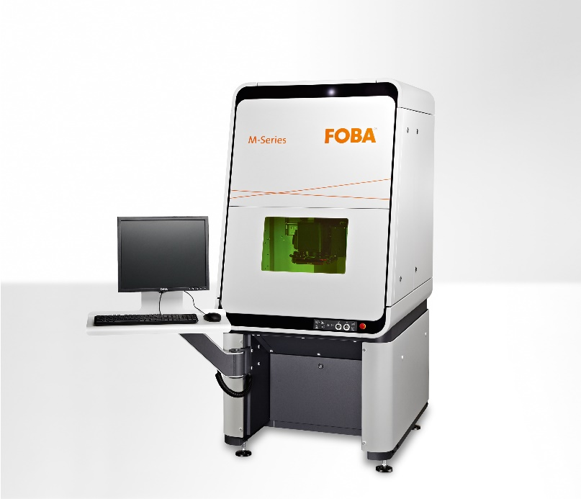

FOBA M2000 is a laser protection class 1 closed laser marking workstation (image rights: FOBA).

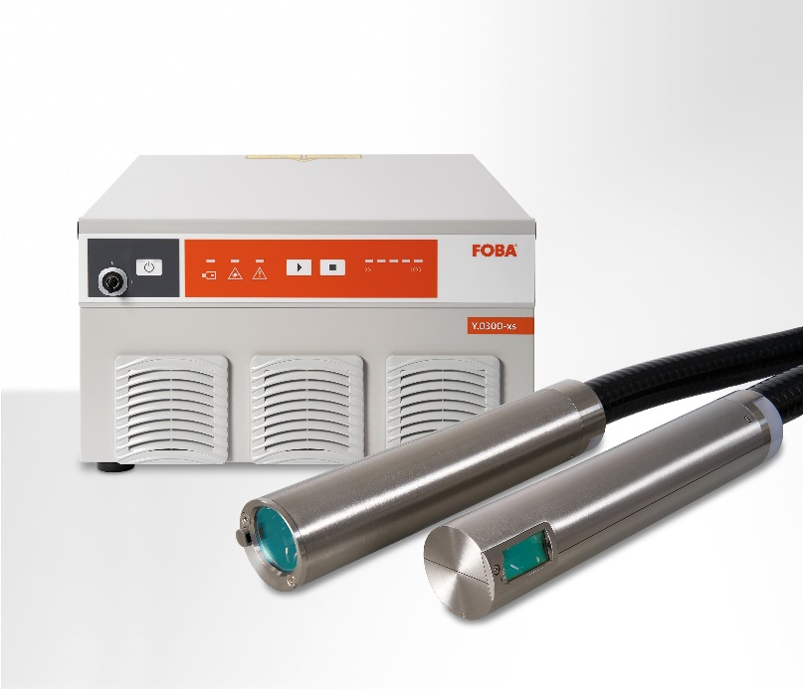

Laser marking head Titus™ is part of FOBA’s fiber laser marking system Y.0X00-xs and can flexibly be ntegrated in the smallest manufacturing units (image rights: FOBA).

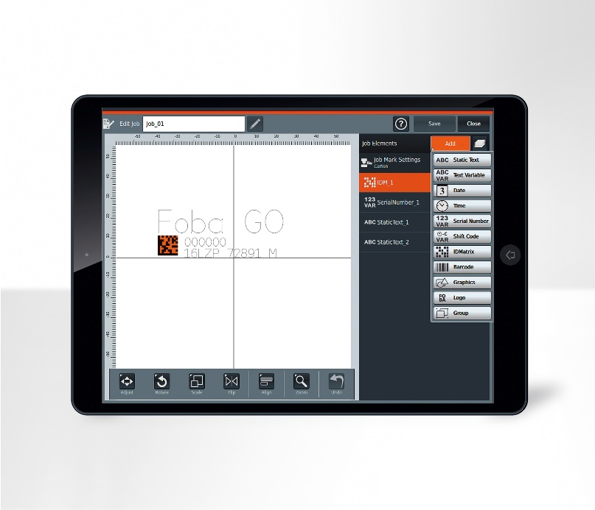

The marking software FOBA Go comes optionally with a tablet or can be controlled via any other device and any browser (image rights: FOBA).

For additional information and images for editorial use please contact:

Susanne Glinz | Campaign Manager | FOBA Marketing Communications
ALLTEC Angewandte Laserlicht Technologie GmbH
An der Trave 27 – 31 | 23923 Selmsdorf
Tel.: +49 (0)38823 55-547
susanne.glinz@fobalaser.com | www.fobalaser.com

About FOBA www.fobalaser.com
FOBA Laser Marking + Engraving (brand of ALLTEC Angewandte Laserlicht Technologie GmbH) is one of the leading suppliers of advanced laser marking systems. FOBA develops and manufactures marking lasers for integration as well as laser marking workstations with vision assisted marking workflows. FOBA technology is being applied for the direct part marking of any kind of metals, plastics or other materials in industries like automotive, medical, electronics, plastics or tool, metal and mold making. With its worldwide sales and service branches and its headquarters near Lübeck/Hamburg (Germany) ALLTEC/FOBA is part of the Danaher Corporation.

