Media Release
June 14, 2022

How to facilitate laser marking integration and set-up – FOBA Webinar on June 16, 2022

Selmsdorf/Wood Dale, June 2022 – “Ready to go”: FOBA Laser Marking + Engraving is hosting a webinar on June 16, 2022, at 9 a.m. CT (4 p.m. CEST), intended for manufacturers who plan to integrate laser marking into production environments with limited space.

The presenters of the webinar are Philipp Febel, Director Product Management, and Jeff Kniptash, Regional Sales Leader Americas. FOBA’s laser marking experts will demonstrate which hardware properties enable flexible installation, and which features make a marking software easy to use and comfortable to apply.

Webinar attendees will learn why the smallest available laser marking head on the market is built to fit into any manufacturing line or plant and how the set-up works practically. With the aim of providing best possible economic efficiency of the laser marking process, FOBA also has developed a software solution called FOBA Go. This user interface is browser-based and can be operated even from mobile devices.

Webinar participation is free of charge; registration is required at https://page.fobalaser.com/FOBA-WBN-FOBAGO-2022-EN_Registration.html?utm_source=pr&utm_medium=pr

FOBA Laser Marking + Engraving
www.fobalaser.com

Find the following and additional images for free download at: https://www.fobalaser.com/newsroom-events/news-press/how-to-facilitate-laser-marking-integration-and-set-up-foba-webinar-on-june-16-2022/

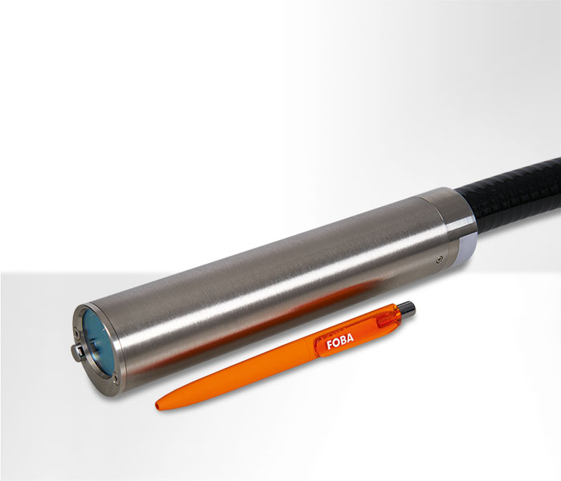
FOBA Titus™ is the world’s smallest available laser marking head for industrial direct part marking. (Image rights: FOBA)
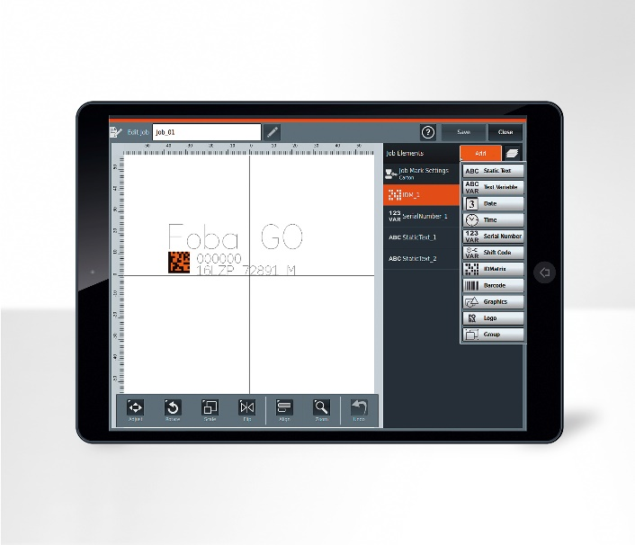
FOBA Go is the most flexible of the three laser marking software solutions from FOBA. The user interface can be operated on any browser-based devices, like a tablet or even a mobile phone.
(Image rights: FOBA)

For additional information and images for editorial use please contact:

Susanne Glinz | Campaign Manager | FOBA Marketing Communications
ALLTEC Angewandte Laserlicht Technologie GmbH
An der Trave 27 – 31 | 23923 Selmsdorf
Tel.: +49 (0)38823 55-547
susanne.glinz@fobalaser.com | www.fobalaser.com

About FOBA www.fobalaser.com
FOBA Laser Marking + Engraving (brand of ALLTEC Angewandte Laserlicht Technologie GmbH) is one of the leading suppliers of advanced laser marking systems. FOBA develops and manufactures marking lasers for integration as well as laser marking workstations with vision assisted marking workflows. FOBA technology is being applied for the direct part marking of any kind of metals, plastics, or other materials in industries like automotive, medical, electronics, plastics or tool, metal and mold making. With its worldwide sales and service branches and its headquarters near Lübeck/Hamburg (Germany) ALLTEC/FOBA is part of the Danaher Corporation.

