Media Release
August 1, 2022

FOBA presents a full scope of laser marking at the IMTS

Wood Dale/ Selmsdorf, August 2022 – FOBA is attending the International Manufacturing Technology Show IMTS in Chicago (September 12 – 17, 2022) with three laser marking systems on site and two sample marking giveaways. Automated mark alignment with FOBA Mosaic, marking on a tube using a rotary unit as well as high-speed in-line marking will be presented, in addition to the latest product developments.

Two M-series marking systems, FOBA M1000 and M2000, and FOBA Titus, a laser marking head for line integration especially in restricted spaces, will be available for laser marking live demonstrations. With various functionalities and integrated camera, each laser system offers advantages and can be selected according to the application requirements and the specific metal or plastic substrate characteristics.

The exhibited M2000 laser marking workstation will be equipped with FOBA Mosaic to demonstrate automated optical mark alignment on parts that are placed randomly in the marking field. Another M-series system on the IMTS, a compact table-top M1000 workstation, will be used with a rotary unit for circumferential marking on metal drinking straws. Visitors can take the straws home as trade show samples from FOBA.

Anodized colored aluminium plates will be another marking sample, used to demonstrate the Titus™ marking system. Titus™ is the smallest marking head on the market and enables high-speed inline processing in manufacturing lines that require much flexibility of integration. Apart from the minimum size of the marking head, it is the simplicity of mounting and a 3- or 10-meter umbilical that contribute to the flexibility of Titus™.

“We are very excited to showcase our solution-based laser technologies at IMTS. We look forward to interacting with our current and prospective customers”, says Jeff Kniptash, FOBA’s Sales Leader Americas. FOBA will be represented at booth number 236024 by nearly all of the US sales engineers as well as international colleagues from product management, sales, and applications. The team is ready to provide laser marking and engraving application advice for visitors from the medical, automotive, aerospace, machining, and many other industries.

FOBA Laser Marking + Engraving
www.fobalaser.com/

More information:
IMTS | International Manufacturing Technology Show
September 12 – 17, 2022 | McCormick Place, Chicago IL
https://www.imts.com/

Find the following and additional images for free download at: https://www.fobalaser.com/newsroom-events/news-press/foba-presents-a-full-scope-of-laser-marking-at-the-imts/

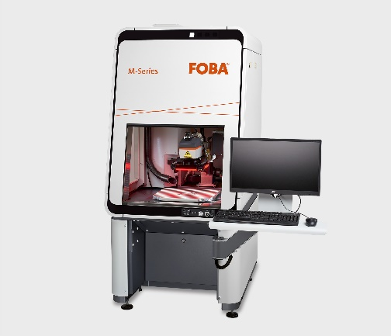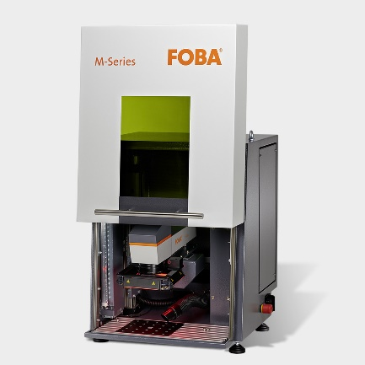
FOBA M-series laser marking workstations M2000 with FOBA Mosaic and M1000, equipped with a rotary unit, will be available for laser marking demonstration at the IMTS trade show. (Image rights: FOBA)

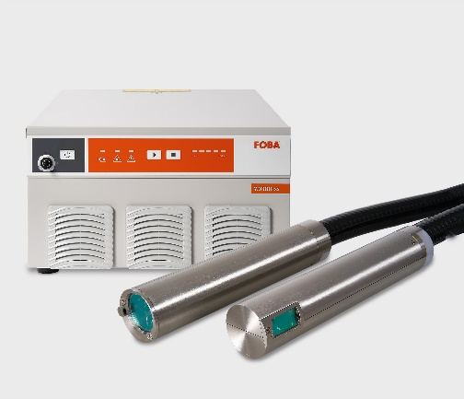
FOBA Titus™ is the smallest marking head on the market and is made for flexible integration into manufacturing lines. (Image rights: FOBA)

For additional information and images for editorial use please contact:

Susanne Glinz | Campaign Manager | FOBA Marketing Communications
ALLTEC Angewandte Laserlicht Technologie GmbH
An der Trave 27 – 31 | 23923 Selmsdorf
Tel.: +49 (0)38823 55-547
susanne.glinz@fobalaser.com | www.fobalaser.com

About FOBA www.fobalaser.com
FOBA Laser Marking + Engraving (brand of ALLTEC Angewandte Laserlicht Technologie GmbH) is one of the leading suppliers of advanced laser marking systems. FOBA develops and manufactures marking lasers for integration as well as laser marking workstations with vision assisted marking workflows. FOBA technology is being applied for the direct part marking of any kind of metals, plastics, or other materials in industries like automotive, medical, electronics, plastics or tool, metal and mold making. With its worldwide sales and service branches and its headquarters near Lübeck/Hamburg (Germany) ALLTEC/FOBA is part of the Danaher Corporation.

