Press Release
March 15, 2022

MD&M West Trade Show: FOBA featuring UDI laser marking together with Spinetti Machinery

Wood Dale, IL/Reno, NV, March 2022 – Together with distribution partner Spinetti Machinery from Reno, NV, FOBA Laser Marking + Engraving is attending MD&M West (Anaheim, CA, April 12-14, 2022). The joint trade show team will provide sample marking on FOBA’s laser marking workstation M2000 live on site to present medical device marking applications.

“We have been working with FOBA for over five years”, says Walter Owens from Spinetti Machinery, “and this show is a welcome opportunity to finally meet business partners and new customers in person again.” Covering the US West coast and most of Canada, Spinetti Machinery is FOBA’s experienced representative in the area. The engineering specialists offer technology support that also includes test marking on FOBA M-series inhouse demo machines.

FOBA's advanced laser marking systems make direct marking in medical device manufacturing a reliable process. “We want to ensure that our clients can meet all the UDI labelling standards as well as upcoming implementation deadlines”, says Christian Söhner, FOBA’s global medical market manager. “Therefore, we provide expert advice and technical benefits to facilitate the implementation and validation of a laser marking process.”

The M-Series laser marking workstations, as well as FOBA’s marking systems for line or machine integration, can optionally be equipped with a camera and visual inspection software. This helps to prevent scrap through pre-mark inspection. It even saves expenses for part fixtures, as with marking feature “Mosaic”, parts can be placed anywhere in the marking field. The integrated camera then aligns the mark accurately and finally verifies marking quality and content.

Any reusable and reprocessed medical devices must bear a directly marked UDI. According to FDA regulations for the US, this will, after risk classes III and II, from September 2022 on also affect class I products such as surgical instruments, dental probes, medical drills and many more. The directly laser marked UDI code must meet quality criteria that ensure permanent readability of the UDI after multiple reprocessing.

At the show, FOBA as a German company that belongs to Danaher corporation, has its booth nr. 2980 at the German Pavilion. Visitors can expect latest product portfolio updates and specific application advice. Individual appointments at the trade show can be requested at info@fobalaser.com

FOBA Laser Marking + Engraving
www.fobalaser.com/

Application Center / Service Center
1500 N Mittel Blvd.
Wood Dale, IL 60191-1072, USA
Sales Support T +1 630 694 3243

More information:
Spinetti Machinery, Reno NV
FOBA distribution partner
https://spinettimachinery.com/

MD&M West | Medical Design and Manufacturing Event
April 12 – 14, 2022 | Anaheim Convention Center, Anaheim CA https://www.mdmwest.com/en/home.html

German Pavilion at MD&M West 2022:
https://mdmwest.german-pavilion.com/en/home/

Find the following and additional images for free download at: https://www.fobalaser.com/newsroom-events/news-press/mdm-west-trade-show-foba-featuring-udi-laser-marking-together-with-spinetti-machinery/

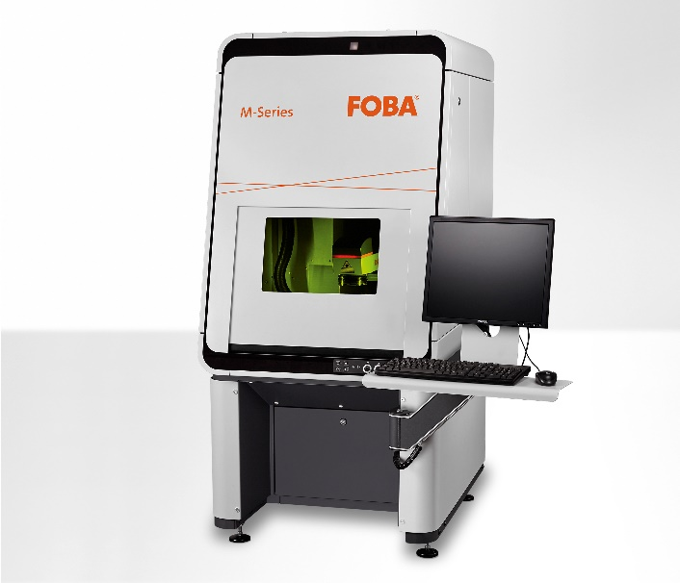
The FOBA M2000 marking workstation is classified laser protection class 1 and can optionally be supplied with the Mosaic software function. (Image rights: FOBA)

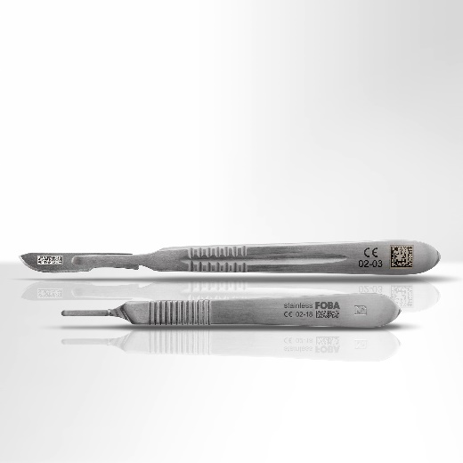
Laser-marked stainless steel medical devices with machine readable data matrix codes and human readable characters. (Image rights: FOBA)

For additional information and images for editorial use please contact:

Susanne Glinz | Campaign Manager | FOBA Marketing Communications
ALLTEC Angewandte Laserlicht Technologie GmbH
An der Trave 27 – 31 | 23923 Selmsdorf
Tel.: +49 (0)38823 55-547
susanne.glinz@fobalaser.com | www.fobalaser.com

About FOBA www.fobalaser.com
FOBA Laser Marking + Engraving (brand of ALLTEC Angewandte Laserlicht Technologie GmbH) is one of the leading suppliers of advanced laser marking systems. FOBA develops and manufactures marking lasers for integration as well as laser marking workstations with vision assisted marking workflows. FOBA technology is being applied for the direct part marking of any kind of metals, plastics or other materials in industries like automotive, medical, electronics, plastics or tool, metal and mold making. With its worldwide sales and service branches and its headquarters near Lübeck/Hamburg (Germany) ALLTEC/FOBA is part of the Danaher Corporation.

