Media Release
April 4, 2022

Laser marking in medical device production: FOBA participates in trade show manufacturing line at MedtecLIVE

Selmsdorf, April 2022 – FOBA Laser Marking + Engraving is taking part in a new presentation format at "MedtecLIVE with T4M" (Stuttgart, May 3 - 5, 2022). For the first time in this form, several partner companies will set up a production line in the exhibition hall. FOBA will demonstrate laser direct marking as part of the value chain of a medical product.

Representing the fifth of a total of seven steps in the production line, FOBA with its M-Series M2000-P laser marking workstation provides the UDI-compliant marking of the trade fair sample. After the three-stage manufacturing, then cleaning, marking and passivation of the component, visitors finally obtain a machine-packaged product to take away.

"This trade show concept is a novelty, not only at the MedtecLIVE with T4M, but also for FOBA and the other participants," says Christian Söhner. "We want to bring individual machine processing steps into a context that is both vivid and tangible, and this is best achieved in presence at a trade show,” adds FOBA's Global Vertical Manager Medical. As a member of the trade fair advisory board, he first came up with the idea for the production line.

Using the example of a metal instrument, each of the seven participating companies represents one of the classic steps in the manufacture of a medical product: from the raw material to the packaged item ready for sale. "Since laser marking is one of the last processing steps, a high reliability of the marking system is crucial to prevent costly incorrect markings," emphasizes Christian Söhner. This could be securely provided by FOBA's camera-based marking systems with upstream and downstream optical inspection and high-precision automated marking alignment.

With a team of application specialists as well as sales consultants, FOBA will also be at trade show booth 10-208. Visitors can learn more about the automated marking alignment capabilities of FOBA's marking software and receive specific application advice. Individual appointments, either for a demonstration on the production line or at the FOBA booth, can be requested at info@fobalaser.com

FOBA Laser Marking + Engraving
www.fobalaser.com/

More information:

MedtecLIVE with T4M – Europe’s leading med tech exhibition
03 – 05 Mai 2022 | Stuttgart, Germany
https://www.medteclive.com/en

Find the following and additional images for free download at: https://www.fobalaser.com/newsroom-events/news-press/laser-marking-in-medical-device-production-foba-participates-in-trade-show-manufacturing-line-at-medteclive/

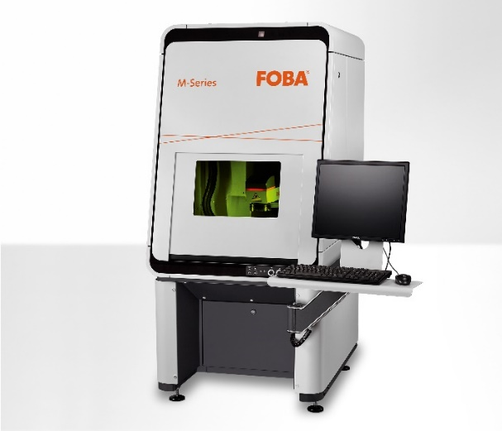
The FOBA M2000 marking workstation is classified laser protection class 1 and can optionally be supplied with the Mosaic marking feature. (Image rights: FOBA)

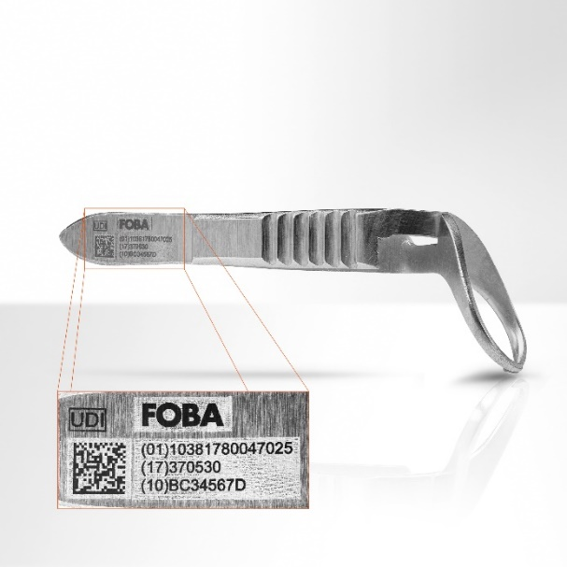
Laser marked stainless steel medical clamp with machine readable UDI code and human readable characters. (Image rights: FOBA)

For additional information and images for editorial use please contact:

Susanne Glinz | Campaign Manager | FOBA Marketing Communications
ALLTEC Angewandte Laserlicht Technologie GmbH
An der Trave 27 – 31 | 23923 Selmsdorf
Tel.: +49 (0)38823 55-547
susanne.glinz@fobalaser.com | www.fobalaser.com

About FOBA www.fobalaser.com
FOBA Laser Marking + Engraving (brand of ALLTEC Angewandte Laserlicht Technologie GmbH) is one of the leading suppliers of advanced laser marking systems. FOBA develops and manufactures marking lasers for integration as well as laser marking workstations with vision assisted marking workflows. FOBA technology is being applied for the direct part marking of any kind of metals, plastics, or other materials in industries like automotive, medical, electronics, plastics or tool, metal and mold making. With its worldwide sales and service branches and its headquarters near Lübeck/Hamburg (Germany) ALLTEC/FOBA is part of the Danaher Corporation.

