Media Release
September 29, 2022

Safe operation of laser systems: FOBA seminars on basic training, housing construction, CE machine qualification

Selmsdorf, September 2022 – Workplace safety has been a top priority at FOBA Laser Marking + Engraving for decades in the development, manufacture and operation of laser marking systems. To support its customers with the safe operation of laser equipment and the implementation of legal requirements, FOBA offers the seminar series "Laser Safety Expertise" (in German language).

The seminar series covers three different topics and provides comprehensive specialist knowledge. Therefore, the seminar participation is suitable for the qualification of laser safety officers, for the construction of secure laser protection housings as well as for the implementation of a CE process for machine classification.

The first seminar imparts basic training for laser safety officers. Due to the high hazard potential, any operator of a laser facility of classes 3 and 4 is legally* obligated to appoint a responsible person, to provide regular further training and to prove his or her current expertise. This includes the ability to perform a risk assessment, which is a special focus of the training.

The technical and formal requirements for the construction of a qualified laser protection housing is the topic of the second seminar. Shielding of optical radiation is an important prerequisite for the safe operation of a laser class 4 system, which is hazardous to health, and thus for the classification of the complete laser facility to the harmless laser class 1.

The third seminar imparts the expert knowledge needed for carrying out the CE process in accordance with the EU Machinery Directive. The participant will learn the formal steps to be taken before placing a laser system on the market, which include extensive documentation. The issuance of a CE Declaration of Conformity is a prerequisite for operating a laser machine in the European Economic Area.

All three seminars can be booked individually and are based on the legal requirements in the field of laser material processing/marking. Potential participants are laser safety officers, design engineers, plant engineers, integrators, and other persons responsible in the field of laser safety.

Appointments can be booked by individual agreement. Seminars are led by FOBA’s experienced safety engineer. For more detailed information, seminar brochures in German language are available for free download. Inquiries about seminar participation or registration can be addressed by e-mail to info@fobalaser.com.

More information and free download of seminar brochures (only in German language): https://page.fobalaser.com/sm-gen03a-Lasersicherheit-Seminare-DE.html?utm_source=website&utm_medium=pr&utm_campaign=lasersicherheit
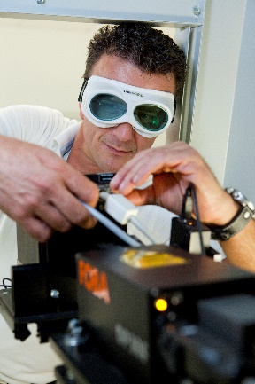
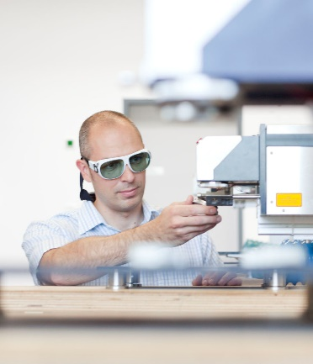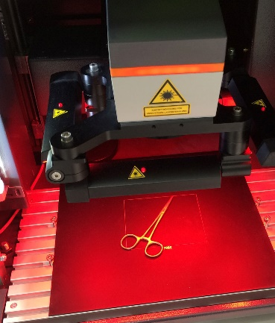

Images for free download:
https://www.fobalaser.com/newsroom-events/news-press/foba-seminars-laser-safety-expertise (image copyright: FOBA Laser Marking + Engraving)

FOBA Laser Marking + Engraving
www.fobalaser.com/

More FOBA media releases:
https://www.fobalaser.com/newsroom-events/news-press/

For additional information and images for editorial use please contact:

Susanne Glinz | Campaign Manager | FOBA Marketing Communications
ALLTEC Angewandte Laserlicht Technologie GmbH
An der Trave 27 – 31 | 23923 Selmsdorf
Tel.: +49 (0)38823 55-547
susanne.glinz@fobalaser.com | www.fobalaser.com

About FOBA www.fobalaser.com
FOBA Laser Marking + Engraving (brand of ALLTEC Angewandte Laserlicht Technologie GmbH) is one of the leading suppliers of advanced laser marking systems. FOBA develops and manufactures marking lasers for integration as well as laser marking workstations with vision assisted marking workflows. FOBA technology is being applied for the direct part marking of any kind of metals, plastics, or other materials in industries like automotive, medical, electronics, plastics or tool, metal and mold making. With its worldwide sales and service branches and its headquarters near Lübeck/Hamburg (Germany) ALLTEC/FOBA is part of the Danaher Corporation.

