Media Release
December 20, 2022

FOBA to showcase medical UDI laser marking at the MD&M West

Selmsdorf/Wood Dale, December 2022 – At the MD&M West trade show in Anaheim, CA (February 7 – 9, 2023) FOBA will be part of the German Pavilion and present its M2000 laser marking workstation on site. FOBA’s camera-assisted laser marking solutions are specifically suited to mark high-quality UDI on medical devices. FOBA also offers expert advice on the implementation of UDI marking according to current legal requirements.

Based on years of cooperation with manufacturers from the medical industry, FOBA provides an integrated approach to UDI direct part marking. This implies advanced laser marking technology as well as a high level of consulting expertise. “Our customers rely on our sophisticated marking solution to make their medical devices compliant with the UDI-requirements according to the FDA and to the European MDR”, says Jeff Kniptash, sales manager Americas.

FOBA’s trade show team will demonstrate a M2000 laser marking workstation live at booth 2978. The system has an integrated camera situated directly in the laser head, which enables automated part detection and mark alignment. “We are excited to welcome our visitors and discuss their specific laser marking requirements. We will also demonstrate live sample laser marking at the booth”, says Jeff Kniptash. “Our laser solutions enable marking results of high precision with superior ease-of-use and speed.”

Laser marks can be applied on any kind of medical products like stainless steel surgical instruments, titanium implants or plastic items for multiple use. Besides its M-series stand-alone laser marking workstations, FOBA also develops and supplies marking systems for manufacturing line integration. FOBA’s three-step marking process includes precise mark alignment, and the pre- and post-marking validation of parts and of marking results. This helps manufacturers to apply marks of high contrast and durability, like UDI codes, while achieving zero waste and a maximum of efficiency.

FOBA Laser Marking + Engraving
www.fobalaser.com/

Find the following and additional images for free download at: https://www.fobalaser.com/newsroom-events/news-presse/2023/foba-to-showcase-medical-udi-laser-marking-at-the-mdm-west/

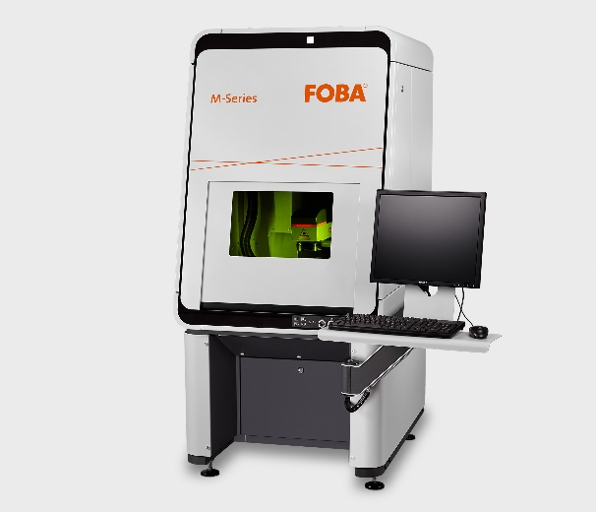
The M2000 laser marking workstation from FOBA’s M-series will be presented at MD&M West 2023. (Image rights: FOBA)

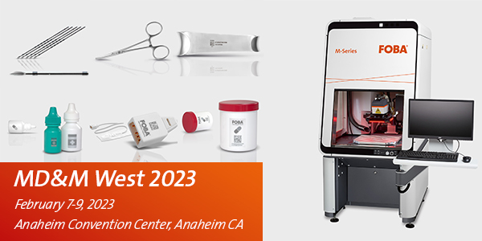
FOBA is showcasing laser marking on medical devices at MD&M West 2023. (Image rights: FOBA)

For additional information and images for editorial use please contact:

Susanne Glinz | Campaign Manager | FOBA Marketing Communications
ALLTEC Angewandte Laserlicht Technologie GmbH
An der Trave 27 – 31 | 23923 Selmsdorf
Tel.: +49 (0)38823 55-547
susanne.glinz@fobalaser.com | www.fobalaser.com

About FOBA www.fobalaser.com
FOBA Laser Marking + Engraving (brand of ALLTEC Angewandte Laserlicht Technologie GmbH) is one of the leading suppliers of advanced laser marking systems. FOBA develops and manufactures marking lasers for integration as well as laser marking workstations with vision assisted marking workflows. FOBA technology is being applied for the direct part marking of any kind of metals, plastics, or other materials in industries like automotive, medical, electronics, plastics or tool, metal and mold making. With its worldwide sales and service branches and its headquarters near Lübeck/Hamburg (Germany) ALLTEC/FOBA is part of the Danaher Corporation.

