**Press Release**

March 27, 2025

**“Ultra” in every aspect - FOBA presents new ultrashort pulse laser**

**Selmsdorf/Wood Dale, March 2025 - FOBA Laser Marking + Engraving, a leading provider of innovative laser marking solutions, will be exhibiting at the upcoming EASTEC 2025, the premier manufacturing trade show on the East Coast. The event will take place from May 13-15, 2025, at the Eastern States Exposition in West Springfield, Massachusetts.**

At booth 3223, FOBA will present its F.0100-ir ultrashort pulse laser, a state-of-the-art marking system designed to deliver ultra-black, corrosion-resistant markings on a variety of materials, including stainless steel, titanium, and plastics. This advanced laser system is set to revolutionize the industry with its unparalleled precision, speed, and compact design.

The F.0100-ir produces deep black, permanent markings that are non-reflective and corrosion-resistant, even after further processing steps such as passivation. “With its adjustable pulse width between the femtosecond and picosecond range, the F.0100-ir ensures minimal heat input, making it ideal for marking heat-sensitive materials without causing damage,” explains Philipp Febel, Director Product Management, Marketing & R&D. Capable of marking various metals and plastics at high speed, the F.0100-ir maintains excellent marking quality, increasing throughput by up to four times. One of the smallest ultrashort pulse marking systems on the market, the F.0100-ir can be easily integrated into production lines and FOBAs M3000 laser marking machine.

EASTEC is the largest manufacturing trade show in the Northeast, providing a platform for industry professionals to explore the latest technologies, network with experts, and discover innovative solutions to manufacturing challenges. The event features over 500 exhibits, keynote panels, and interactive theaters, making it an ideal venue for FOBA to showcase its cutting-edge laser marking solutions.

FOBA invites all attendees to visit booth 3223 to experience live demonstrations of the F.0100-ir ultrashort pulse laser and learn how this revolutionary technology can enhance manufacturing processes. FOBA's experts will be on hand to answer questions and discuss the benefits of integrating lase rmarking into various applications, including electronics industries, automotive, and medical technology.

For more information about FOBA and its innovative laser marking solutions, please visit <https://www.fobalaser.com/>

**Further Information:**

EASTEC | Manufacturing Technology Series EAST  
May 13-15 | Eastern States Exposition, West Springfield, MA [https://east.mtseries.com/](https://www.mdmwest.com/en/home.html)

**Images for editorial use**

**Images can be downloaded free of charge for editorial use at:**

<https://www.fobalaser.com/newsroom-events/news-press/foba-presents-new-ultrashort-pulse-laser-at-eastec/>

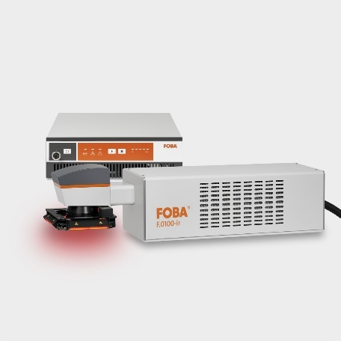

FOBA’s ultrashort pulse laser F.0100-ir for deep black and non-reflective markings. (Copyright: FOBA)

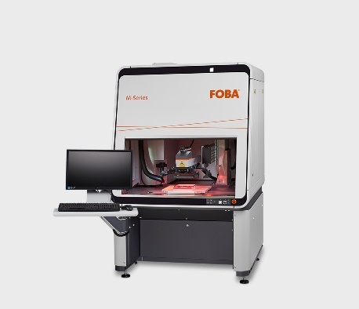

Laser Marking Station M3000 with vision inspection for economic direct part marking and reliable product traceability. (Copyright: FOBA)

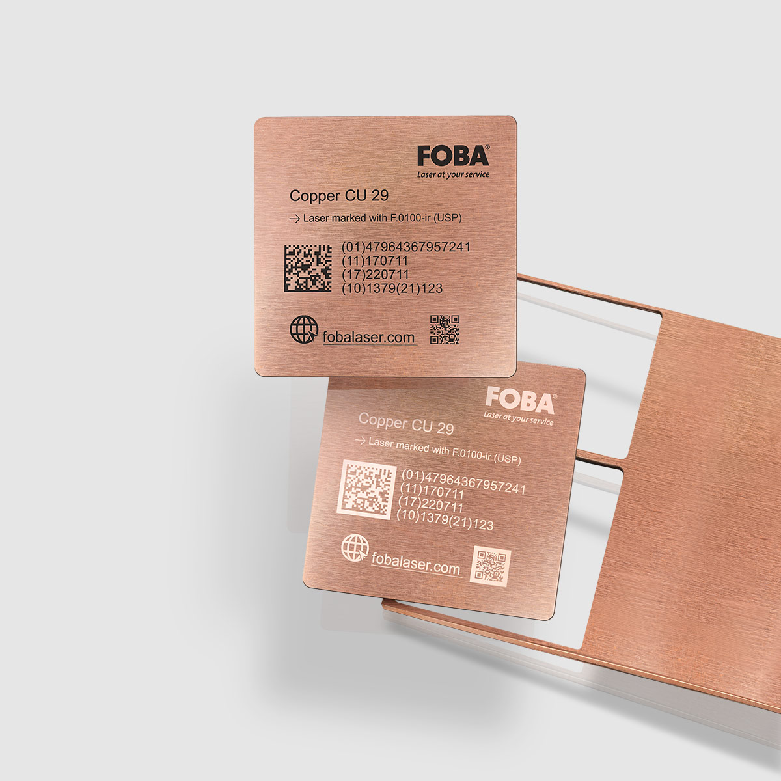

Copper plate marked with the ultrashort pulse laser. (Copyright: FOBA)

For additional information and images for editorial use please contact:

**Kathrin Urban |** Campaign & Event Manager

**ALLTEC Angewandte Laserlicht Technologie GmbH** | FOBA Laser Marking + Engraving  
An der Trave 27 – 31 | 23923 Selmsdorf

Tel.: +49 (0)38823 55-440

[kathrin.urban@fobalaser.com](mailto:kathrin.urban@fobalaser.com) | [www.fobalaser.com](http://www.fobalaser.com)

**About FOBA** [**www.fobalaser.com**](http://www.fobalaser.com)

FOBA Laser Marking + Engraving (brand of ALLTEC Angewandte Laserlicht Technologie GmbH) is one of the leading suppliers of advanced laser marking systems. FOBA develops and manufactures marking lasers for integration as well as laser marking workstations with vision assisted marking workflows. FOBA technology is being applied for the direct part marking of any kind of metals, plastics, or other materials in industries like automotive, medical, electronics, plastics or tool, metal and mold making. With its worldwide sales and service branches and its headquarters near Lübeck/Hamburg (Germany) ALLTEC/FOBA is part of the Veralto Corporation.